University of Seville  
 School of Computer Engineering

**Performance Report**



Software engineering  
Design and testing 2

2018 – 2019

04/21/2019

Group 26

**Index**

1. Observations 3

2. Position 3

Create 3

Edit 5

Delete 7

Conclusion 9

3. Mess 10

Search by tags, list by that tag and display a mess 10

Send a message 11

Delete a message 13

Send a broadcast mess 15

Conclusion 16

4. Dashboard 17

Display the dashboard and set the spammers 17

Conclusion 18

5. Configuration 19

Display the configuration and edit it 19

Conclusion 21

6. Problem 21

Create 21

Edit 23

Delete 25

Conclusion 27

7. Finder 27

Search and clear 27

Conclusion 29

8. Curricula 29

Create a curriculum 29

Delete a curriculum 31

9. Datas (Personal, Education, Position and Miscellaneous data) 33

Create all datas 33

Edit a position data 35

Edit a education data 37

Edit a miscellaneous data 39

Delete a position data 40

Delete a education data 42

Delete a miscellaneous data 44

Conclusion 46

10. Social profile 46

Create 46

Edit 48

Delete 51

Conclusion 52

11. Actor 53

Create 53

Edit 55

Delete 57

Conclusion 59

12. Application 59

Create 59

Edit 61

Delete 63

Conclusion 65

13. Audit 65

Assign 65

Create 67

Edit 70

Delete 72

Conclusion 74

14. Sponsorship 75

Create 75

Edit 77

Delete 79

Conclusion 80

15. Item 81

Create 81

Edit 83

Delete 85

Conclusion 86

16. Conclusion of the performance 87

# Observations

We have considered that our performance tests were valid as long as they were lasting between 2’5 and 3 seconds and no error was showed.

# TODO DE AQUI PABAJO SE BORRA

# Position

## Create

Sequence:

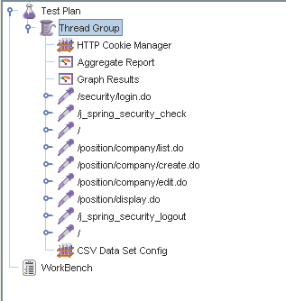

Aggregate Report:

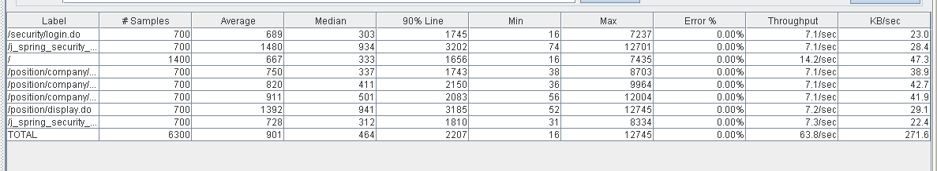

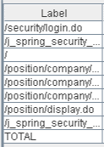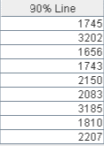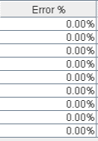

Thread properties:

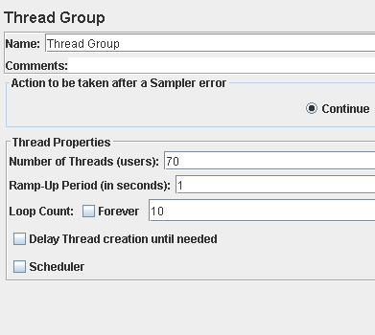

Graph Results:

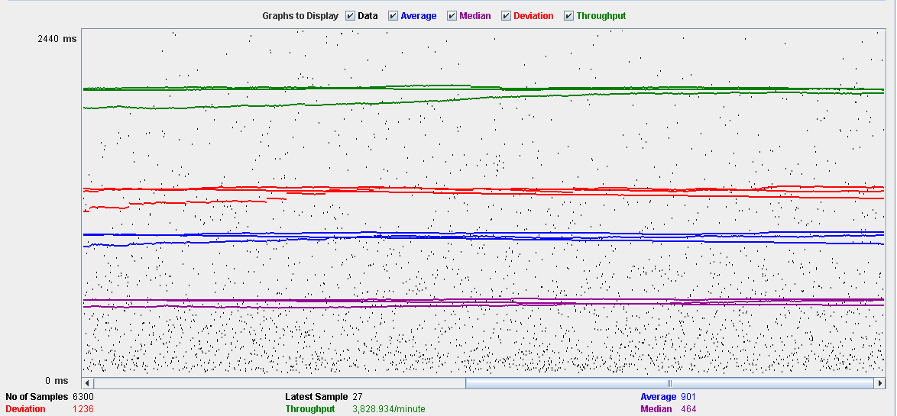

Performance Results:

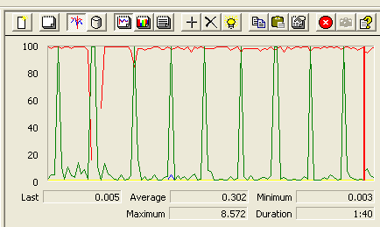

The CPU was always at its limit while the disk usage showed many peaks.

## Edit

Sequence:

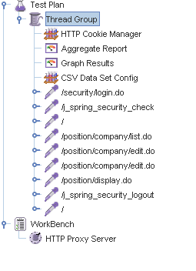

Aggregate Report:

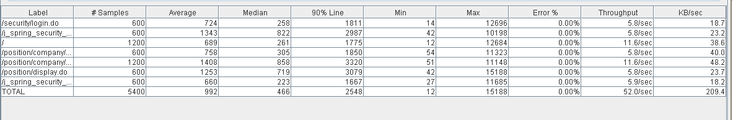

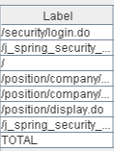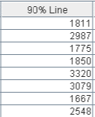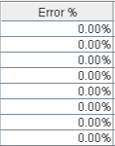

Thread properties:

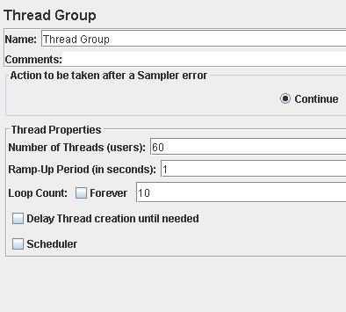

Graph Results:

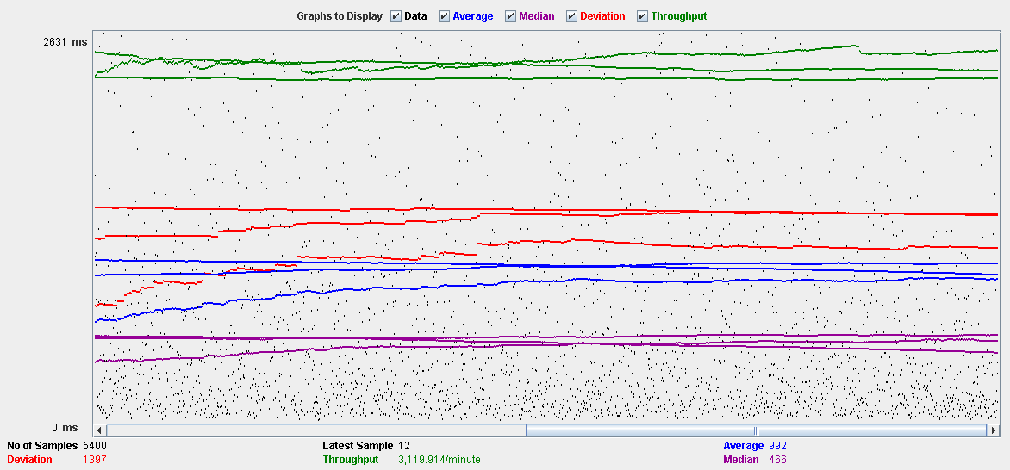

Performance Results:

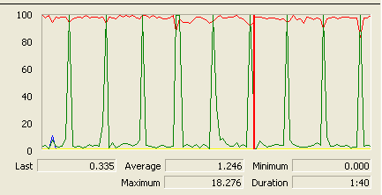

Again we can see that the CPU is always being used while the disk usage shows some periodic peaks.

## Delete

Sequence:

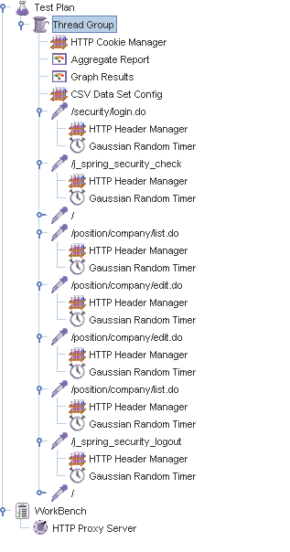

Aggregate Report:

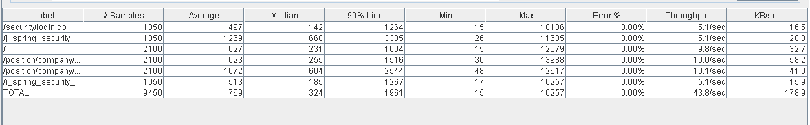

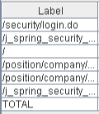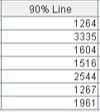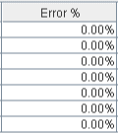

Thread properties:

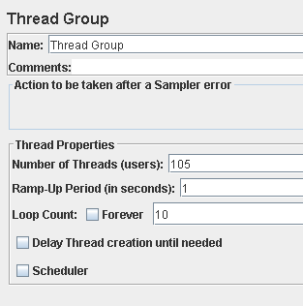.

Graph Results:

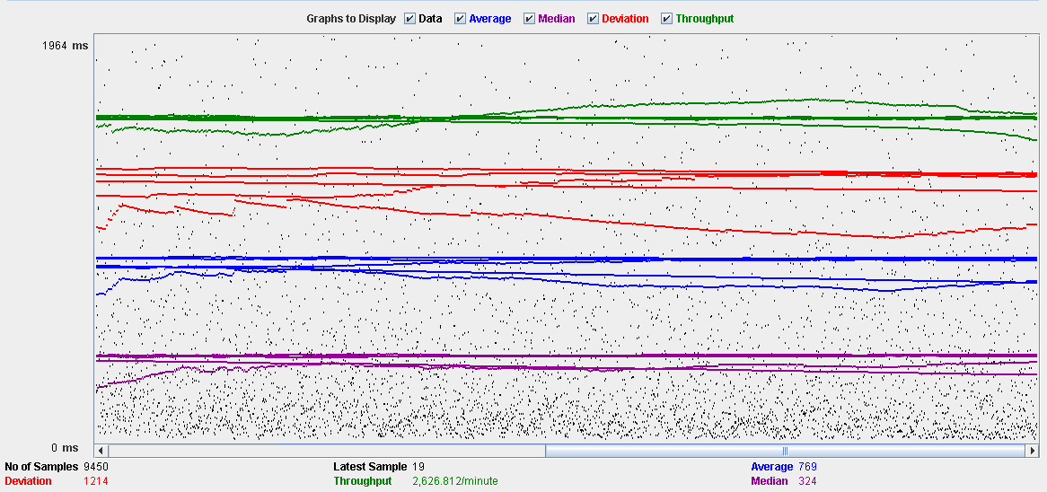

Performance Results:

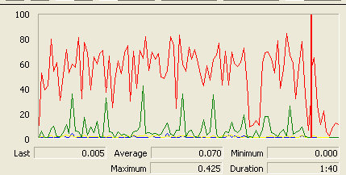

Again we can see that the CPU is always being used while the disk usage shows some peaks.

## Conclusion

The test was performed using:

CPU: 5 2500k (2 cores in the virtual machine)

RAM: 2 GB (virtual machine)

For this use case we can say that the limitation occurs during the edit process, being the maximum of concurrent users 60 because the time of respond starts to be very high at that point.

# Mess

## Search by tags, list by that tag and display a mess

Sequence:

Aggregate Report:

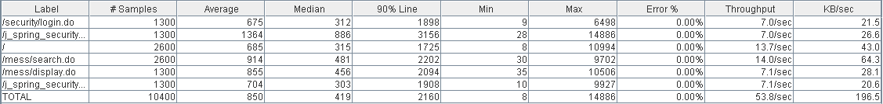

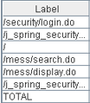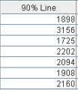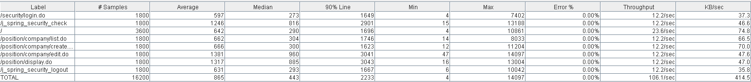

Thread properties:

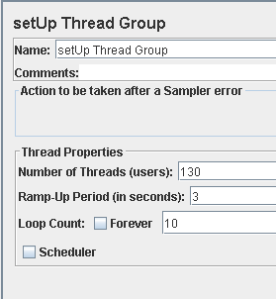

Graph Results:

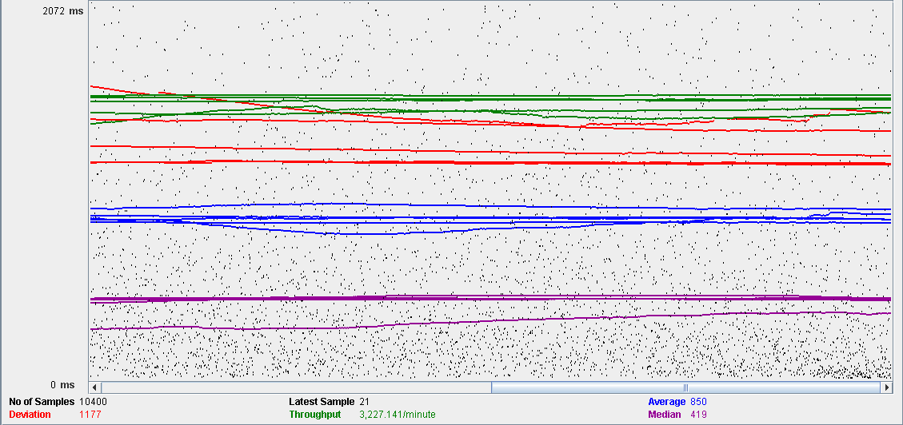

Performance Results:

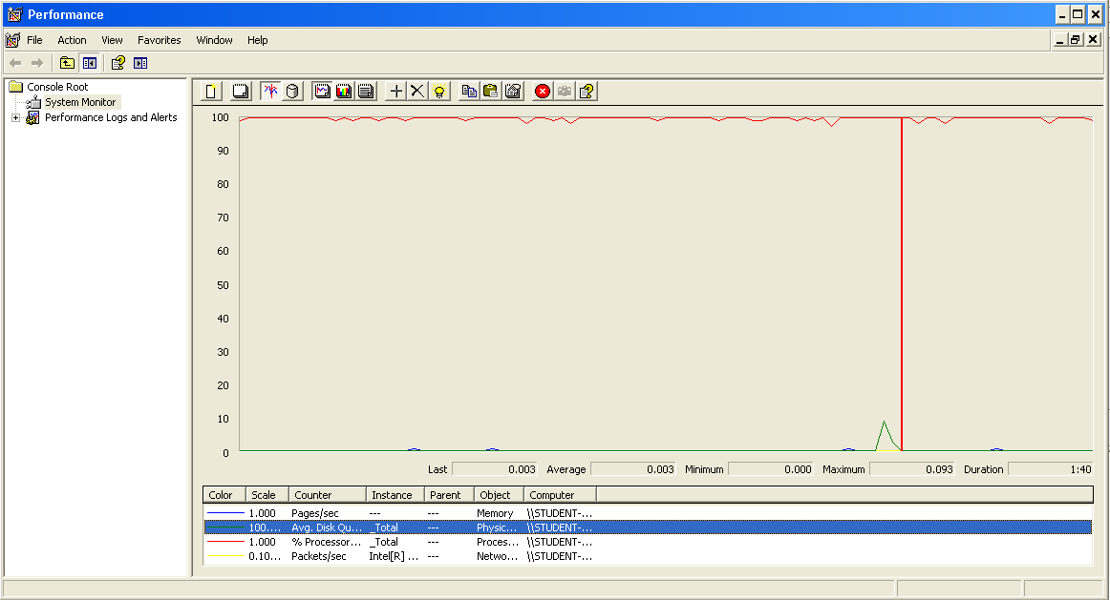

The CPU was always at its limit while the disk usage showed many peaks.

## Send a message

Sequence:

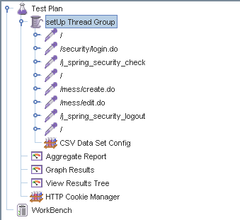

Aggregate Report:



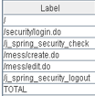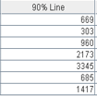

Thread properties:

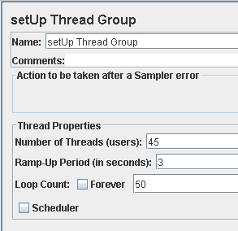

Graph Results:

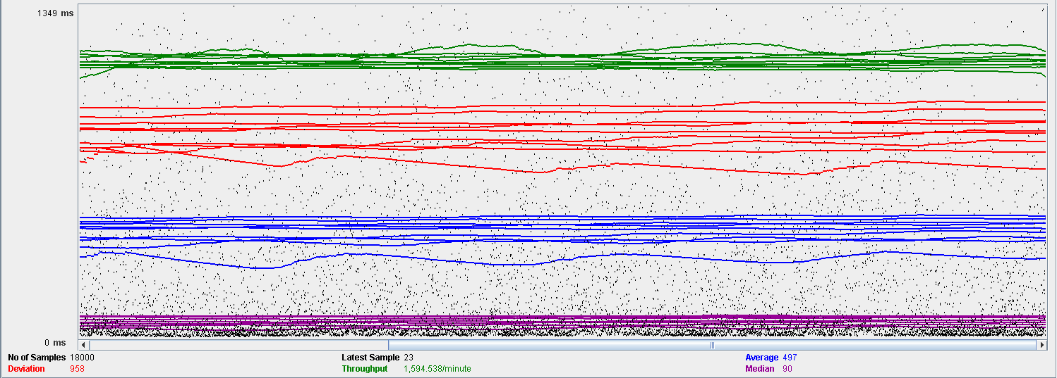

Performance Results:

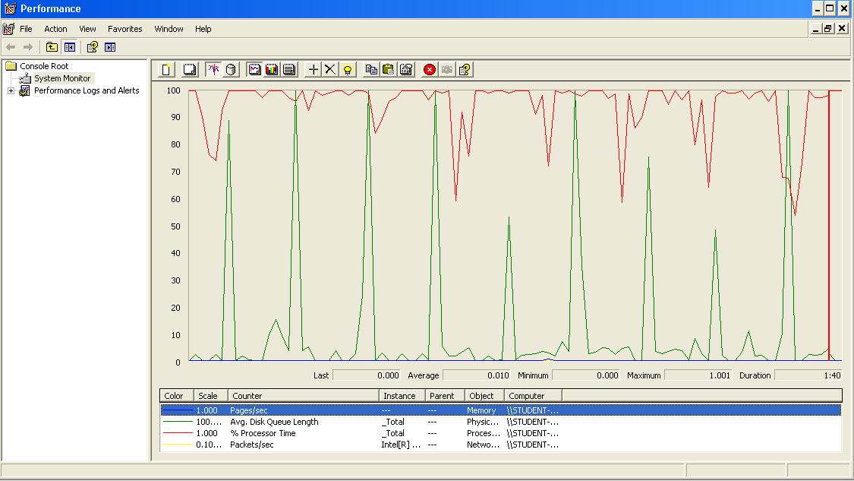

Again we can see that the CPU is always being used while the disk usage shows some periodic peaks.

## Delete a message

Sequence:

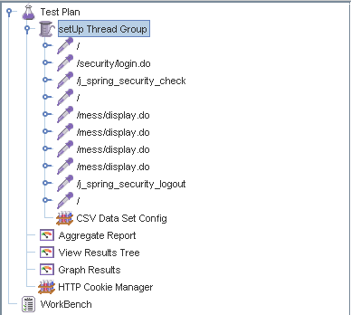

Aggregate Report:

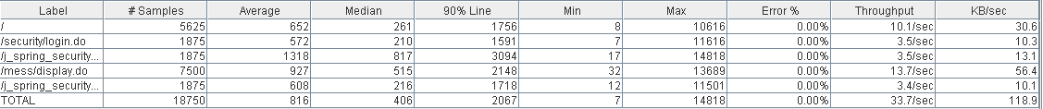

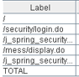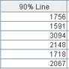

Thread properties:

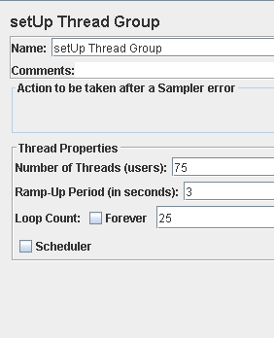

Graph Results:

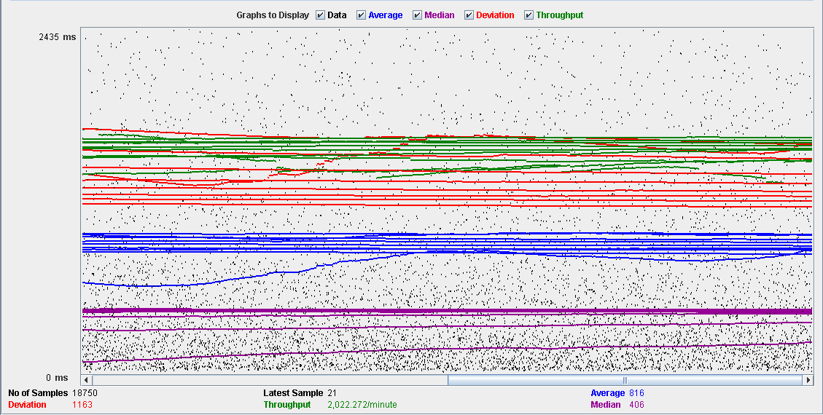

Performance Results:

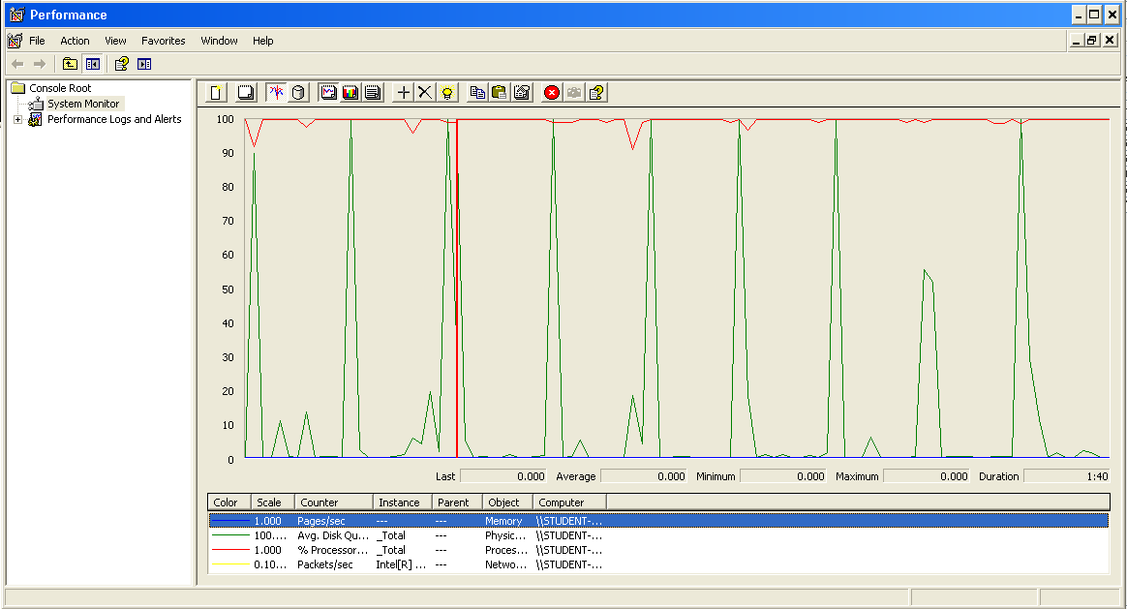

Again we can see that the CPU is always being used while the disk usage shows some periodic peaks.

## Send a broadcast mess

Sequence:

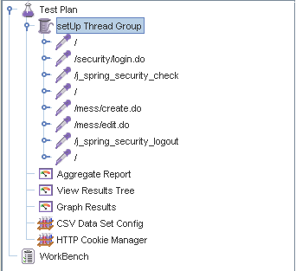

Aggregate Report:

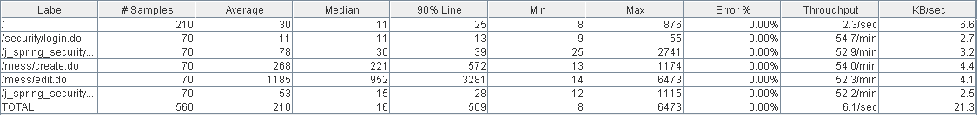

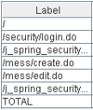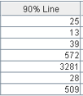

Thread properties:

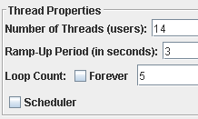

Graph Results:

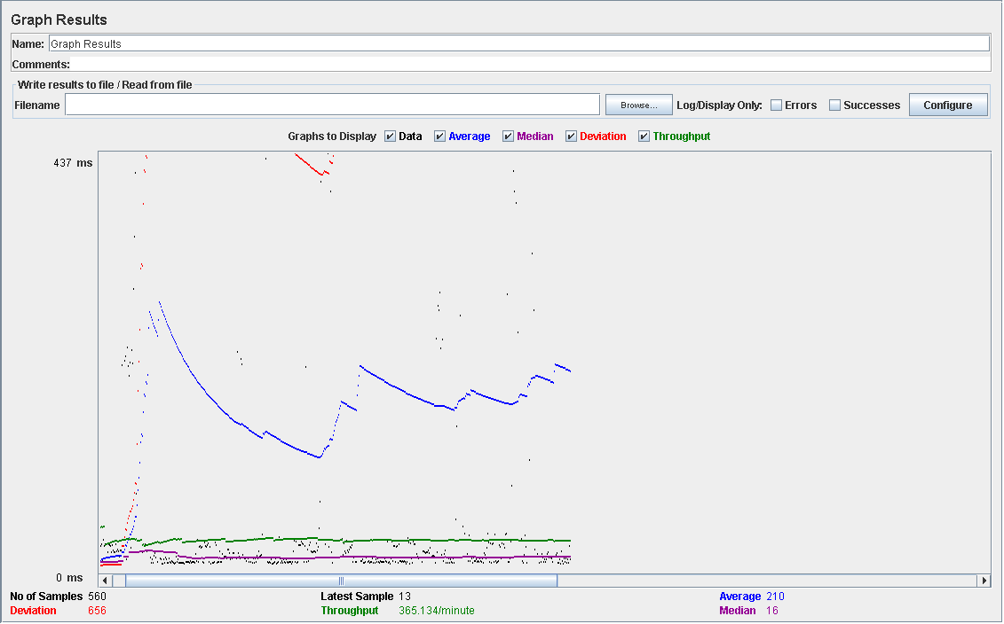

Performance Results:

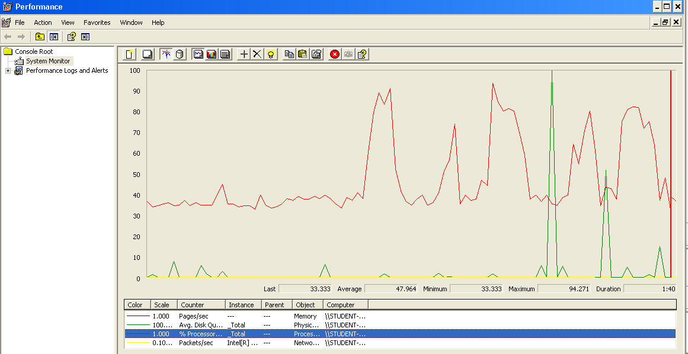

Again we can see that the CPU is always being used while the disk usage shows some peaks.

## Conclusion

The test was performed using:

CPU: i7 7700HQ (2 cores in the virtual machine)

RAM: 2 GB (virtual machine)

For this use case we can say that the limitation occurs during the creation process, being the maximum of concurrent users 14.

# Dashboard

## Display the dashboard and set the spammers

Sequence:

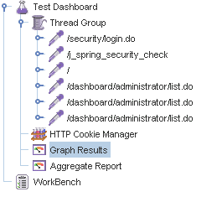

Aggregate Report:

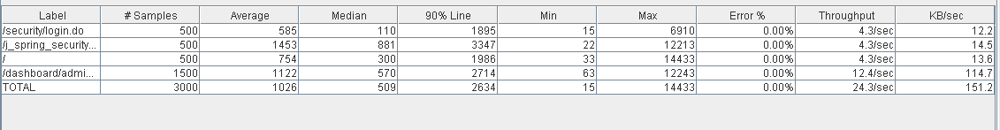

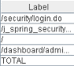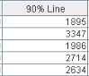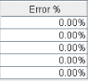

Thread properties:

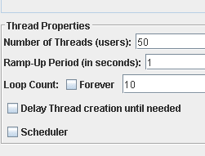

Graph Results:

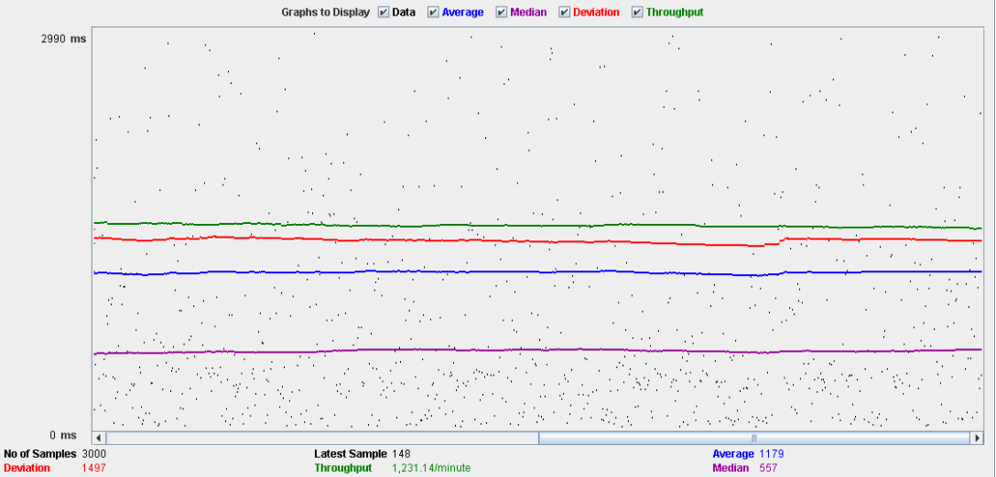

Performance Results:

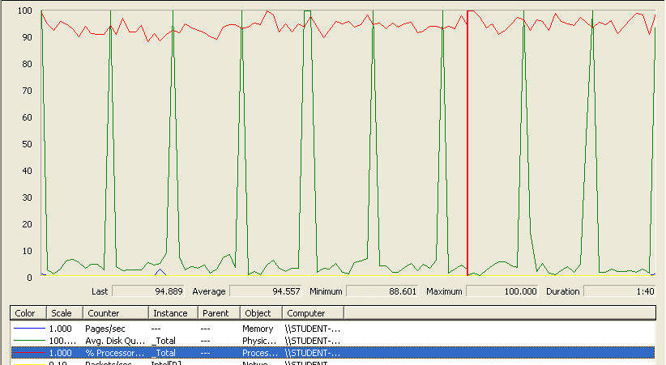

The CPU was always at its limit while the disk usage showed many peaks.

## Conclusion

The test was performed using:

CPU: i5 2500K (2 cores in the virtual machine)

RAM: 2 GB (virtual machine)

For this use case we can say that the limitation occurs around 50 users when the time of respond begins to be very high.

# Configuration

## Display the configuration and edit it

Sequence:

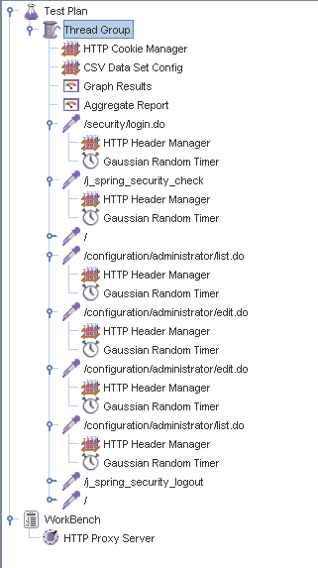

Aggregate Report:

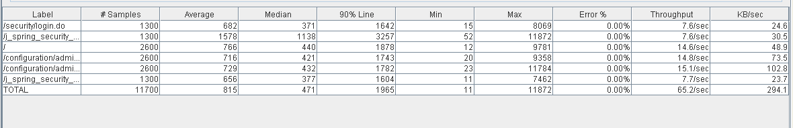

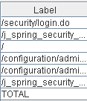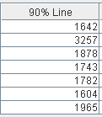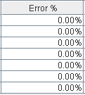

Thread properties:

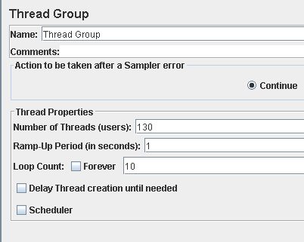

Graph Results:

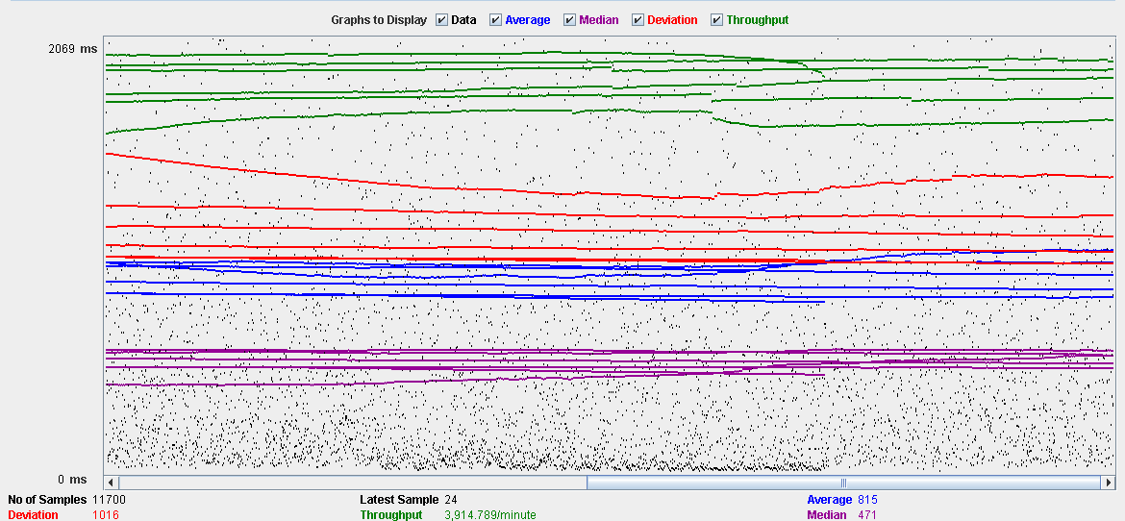

Performance Results:

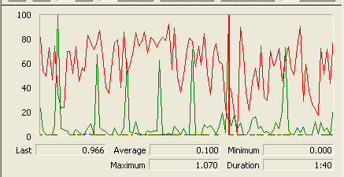

The CPU was always at its limit while the disk usage showed many peaks.

## Conclusion

The test was performed using:

CPU: i5 2500K (2 cores in the virtual machine)

RAM: 2 GB (virtual machine)

For this use case we can say that the limitation occurs around 130 users when the time of respond begins to be very high.

# Problem

## Create

Sequence:

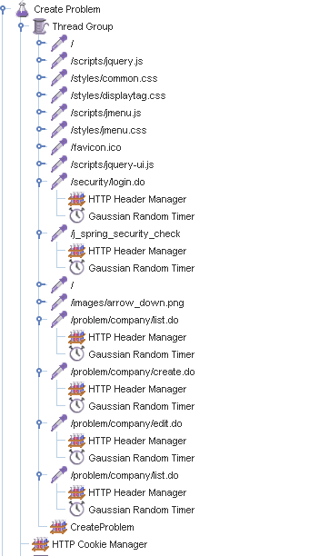

Aggregate Report:

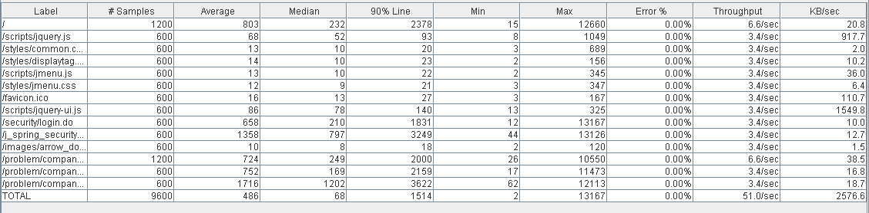

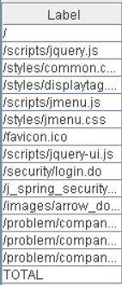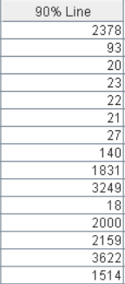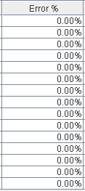

Thread properties:

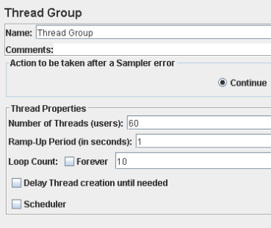

Graph Results:

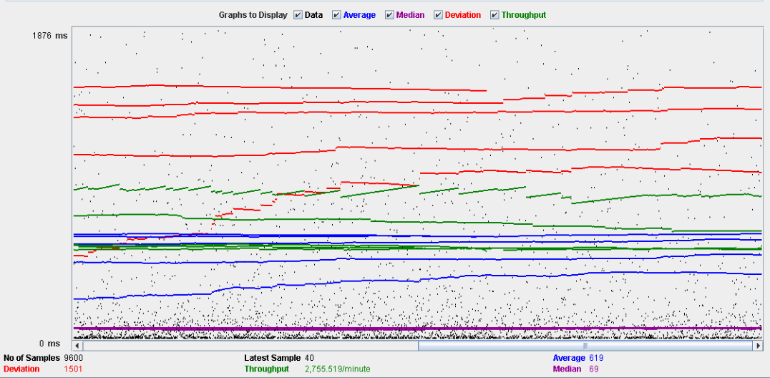

Performance Results:

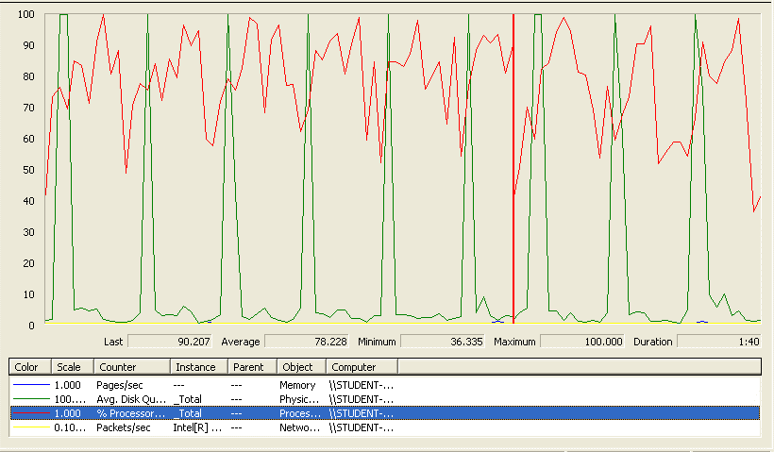

The CPU was always at its limit while the disk usage showed many peaks.

## Edit

Sequence:

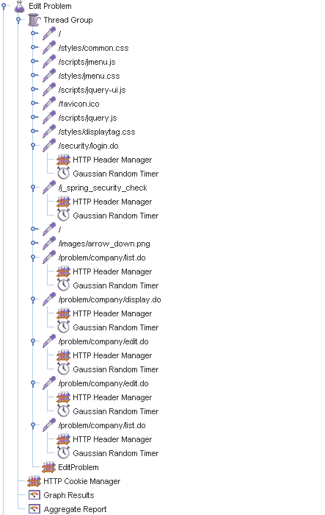

Aggregate Report:

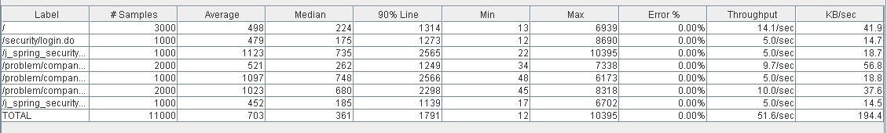

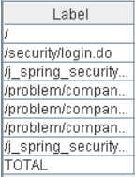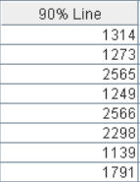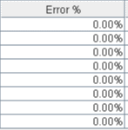

Thread properties:

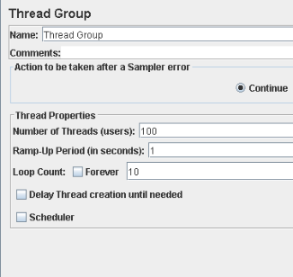

Graph Results:

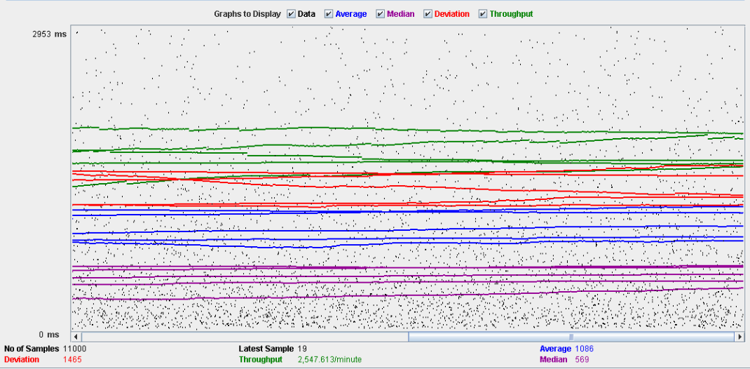

Performance Results:

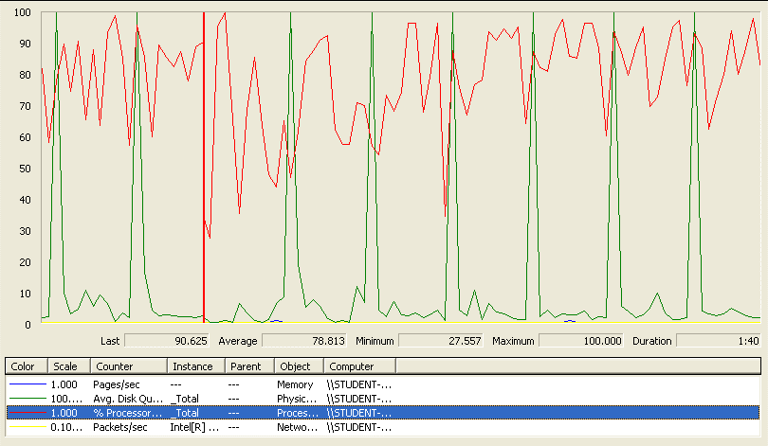

Again we can see that the CPU is always being used while the disk usage shows some periodic peaks.

## Delete

Sequence:

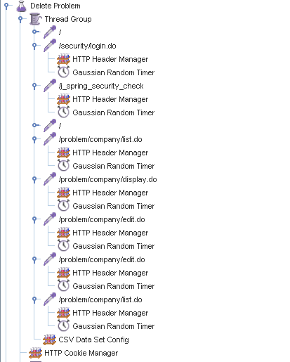

Aggregate Report:

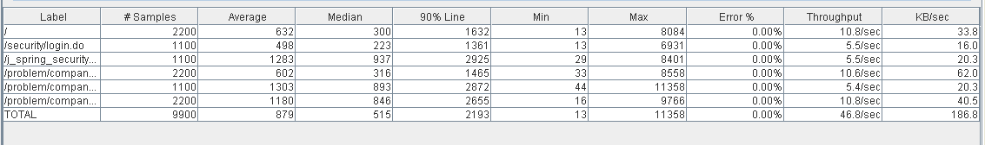

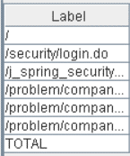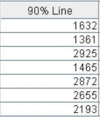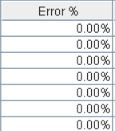

Thread properties:

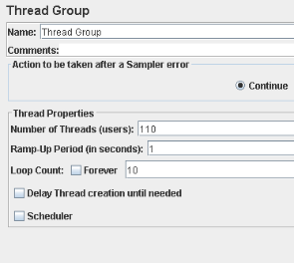

Graph Results:

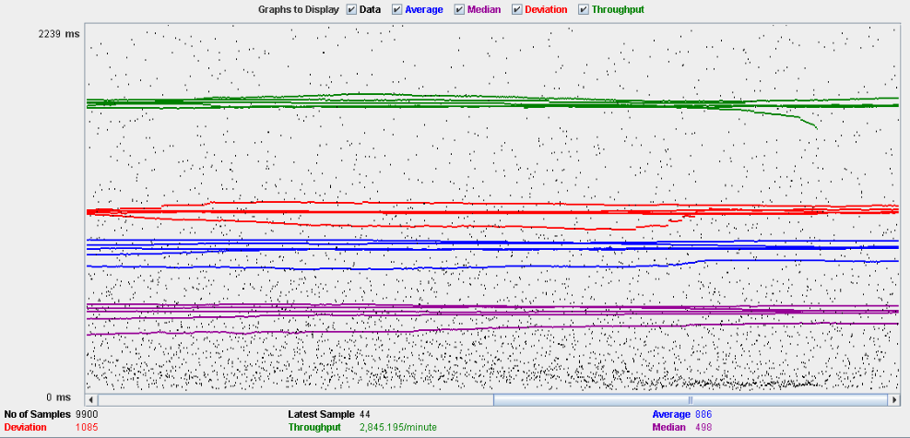

Performance Results:

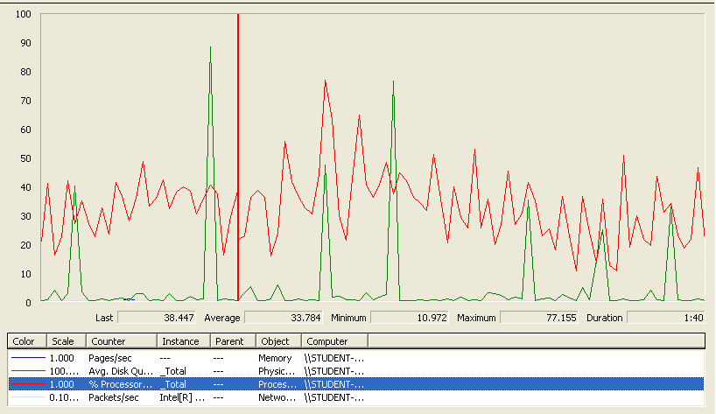

Again we can see that the CPU is always being used while the disk usage shows some periodic peaks.

## Conclusion

The test was performed using:

CPU: i5 2500k (2 cores in the virtual machine)

RAM: 2 GB (virtual machine)

For this use case we can say that the limitation occurs during the create process, being the maximum of concurrent users 60 because the time of respond begins to be very high.

# Finder

## Search and clear

Sequence:

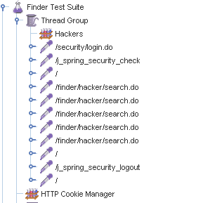

Aggregate Report:



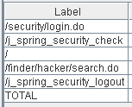 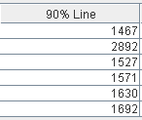 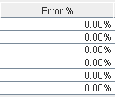

Thread properties:

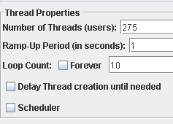

Graph Results:

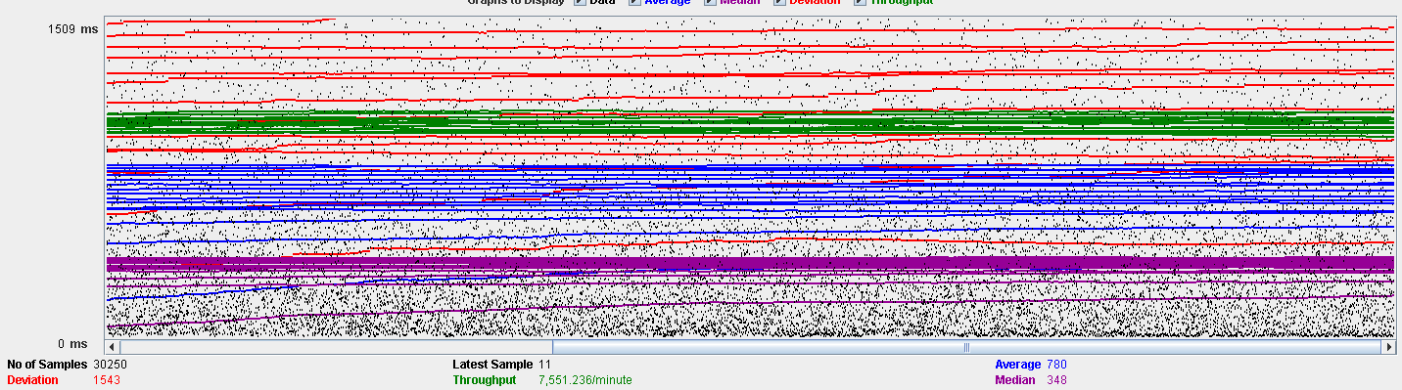

Performance Results:

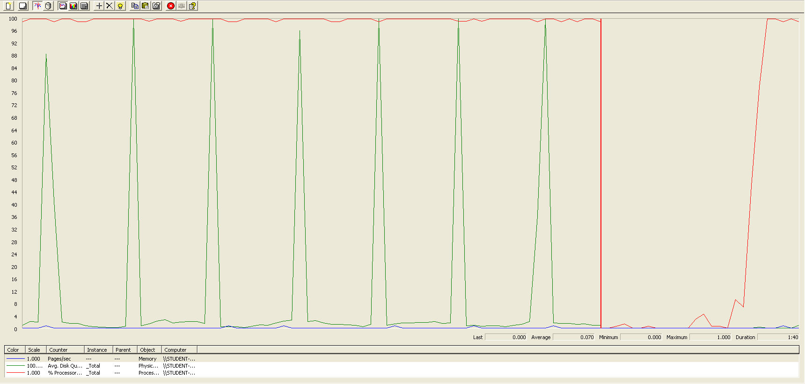

The CPU was always at its limit while the disk usage showed many peaks.

## Conclusion

The test was performed using:

CPU: i7 7300hq (2 cores in the virtual machine)

RAM: 2 GB (virtual machine)

For this use case we can say that the limitation is with a maximum of 275 concurrent users.

# Curricula

## Create a curriculum

Sequence:

Aggregate Report:

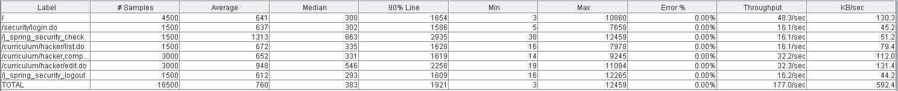



Thread properties:



Graph Results:

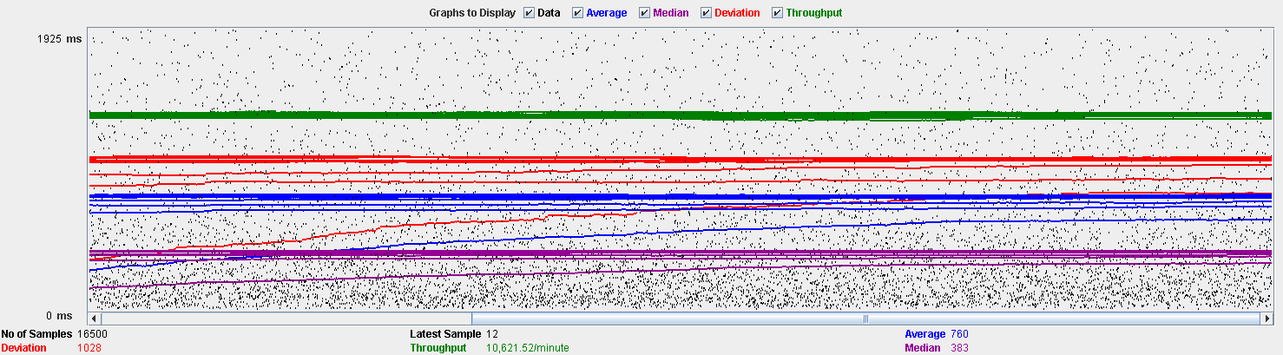

Performance Results:



The CPU was always at its limit while the disk usage showed many peaks.

## Delete a curriculum

Sequence:

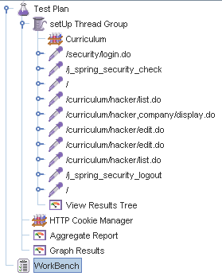

Aggregate Report:

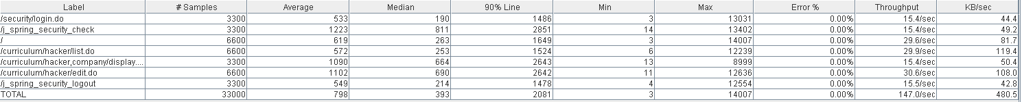



Thread properties:

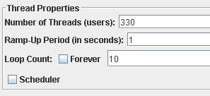

Graph Results:

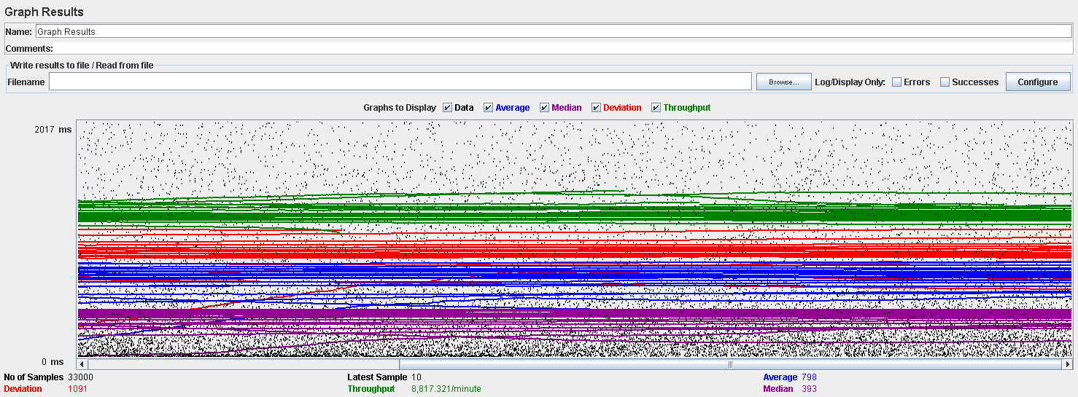

Performance Results:

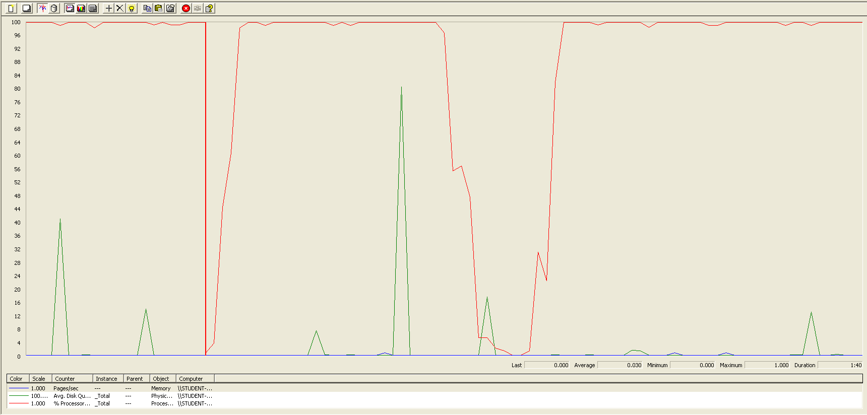

Again we can see that the CPU is always being used while the disk usage shows some little peaks.

# Datas (Personal, Education, Position and Miscellaneous data)

## Create all datas

Sequence:

Aggregate Report:

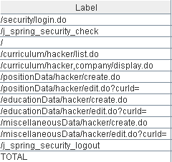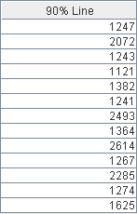

Thread properties:

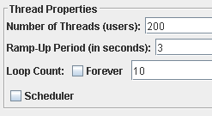

Graph Results:

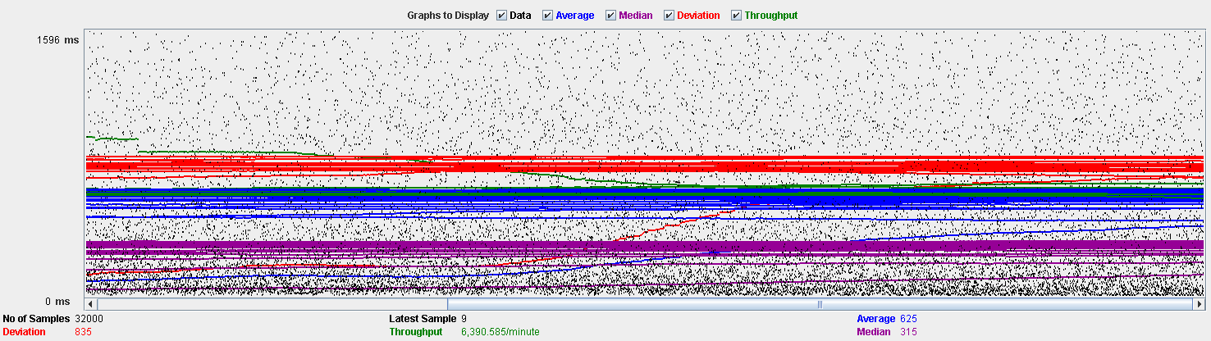

Performance Results:

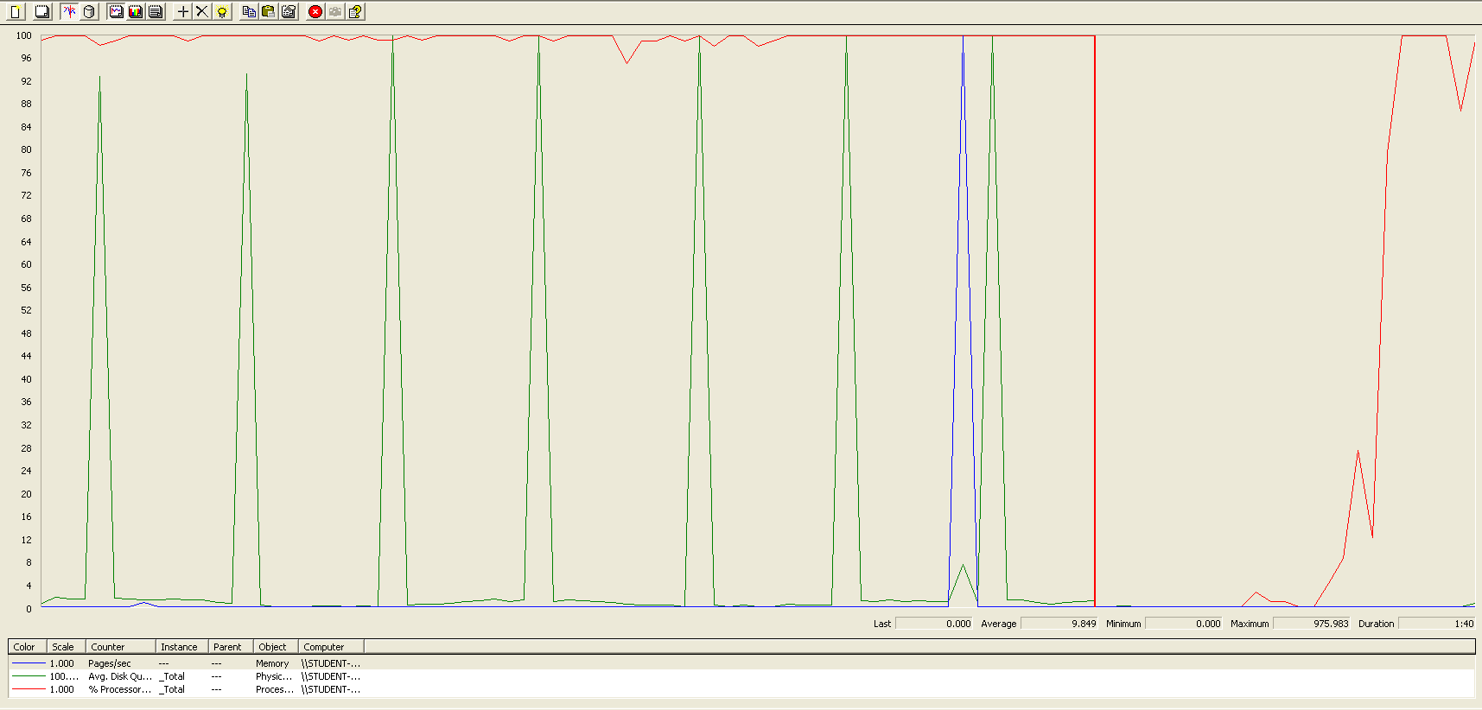

Again we can see that the CPU is always being used while the disk usage shows some periodic peaks.

## Edit a position data

Sequence:

Aggregate Report:

Thread properties:

Graph Results:

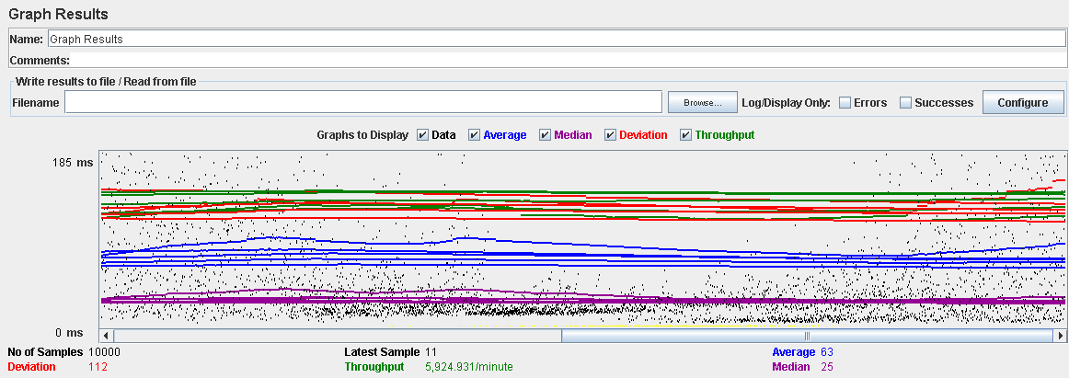

Performance Results:

Again we can see that the CPU is always being used while the disk usage shows some peaks.

## Edit a education data

Sequence:

Aggregate Report:

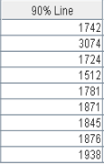

Thread properties:

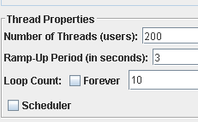

Graph Results:

Performance Results:

Again we can see that the CPU is always being used while the disk usage shows some peaks.

## Edit a miscellaneous data

Sequence:

Aggregate Report:

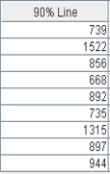

Thread properties:

Graph Results:

Performance Results:

Again we can see that the CPU is always being used while the disk usage shows some peaks.

## Delete a position data

Sequence:

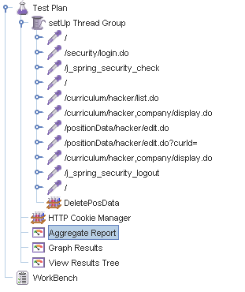

Aggregate Report:

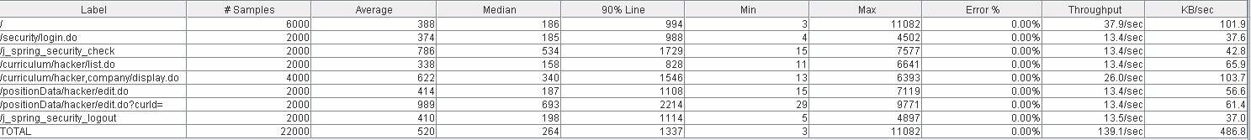

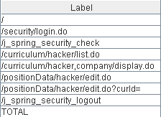 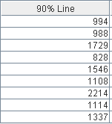

Thread properties:

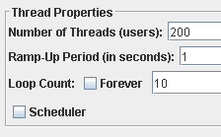

Graph Results:

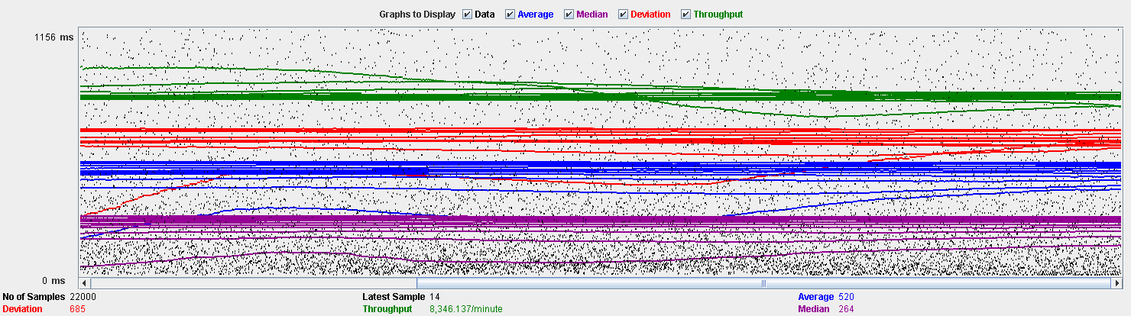

Performance Results:

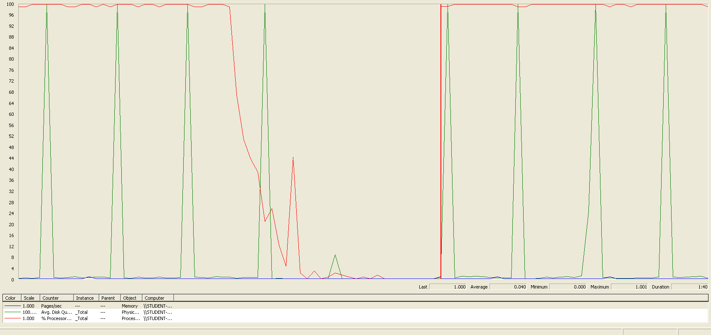

Again we can see that the CPU is always being used while the disk usage shows some peaks.

## Delete a education data

Sequence:

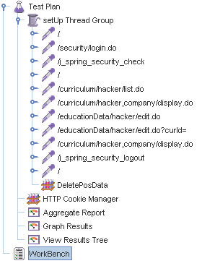

Aggregate Report:

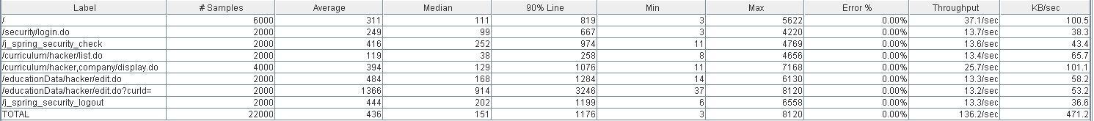

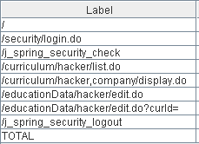 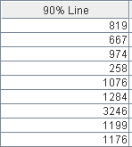

Thread properties:



Graph Results:

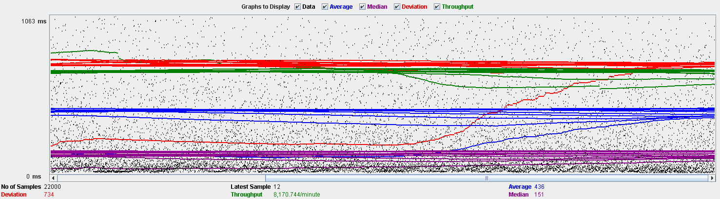

Performance Results:

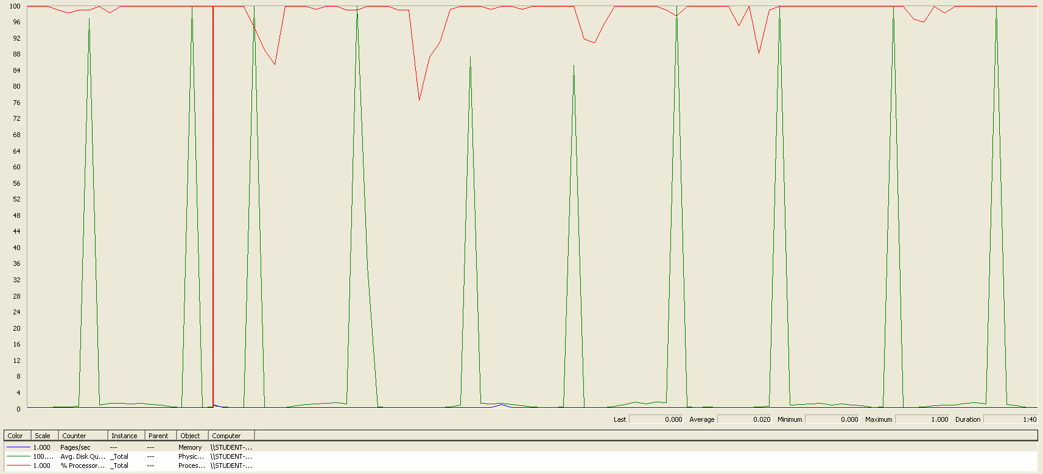

Again we can see that the CPU is always being used while the disk usage shows some peaks.

## Delete a miscellaneous data

Sequence:

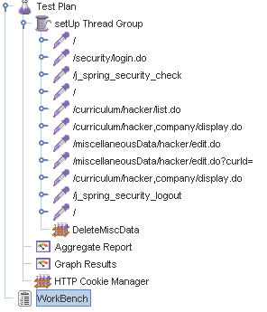

Aggregate Report:

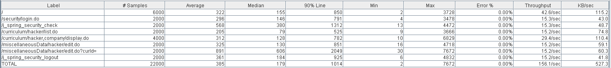

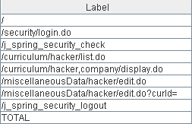 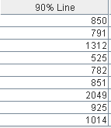

Thread properties:



Graph Results:

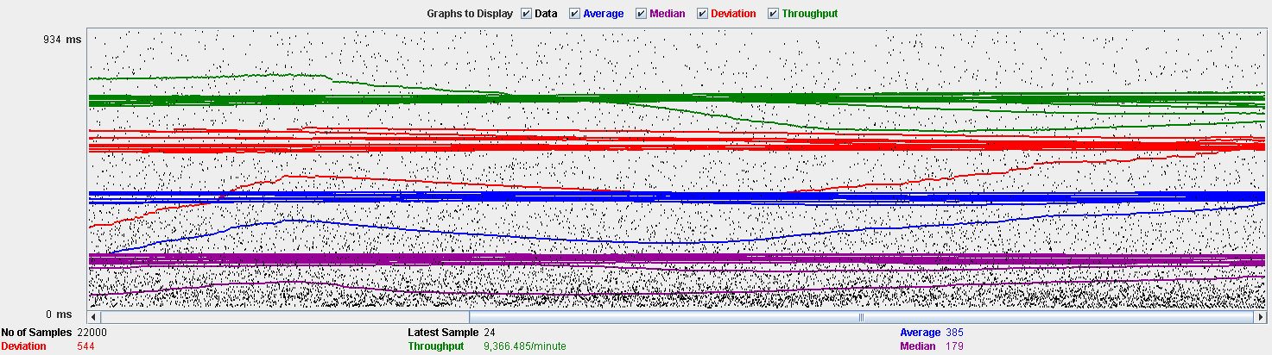

Performance Results:

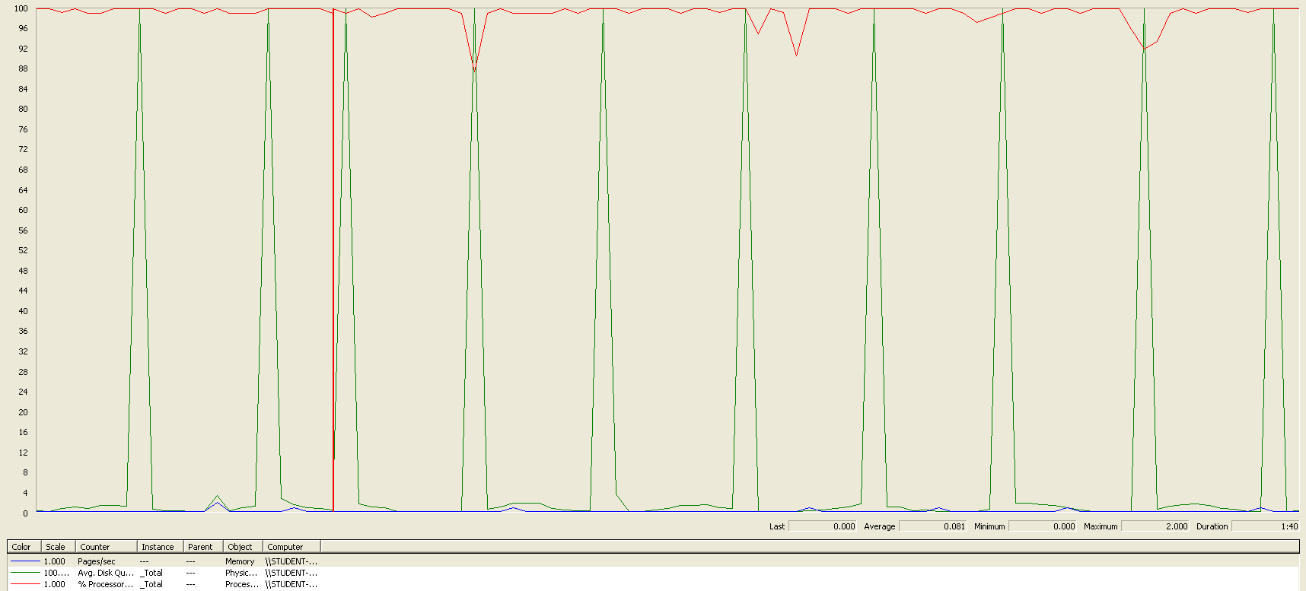

Again we can see that the CPU is always being used while the disk usage shows some peaks.

## Conclusion

The test was performed using:

CPU: i7 6700hq (2 cores in the virtual machine)

RAM: 4 GB (virtual machine)

For this use case we can say that the limitation occurs during the creation process, being the maximum of concurrent users 180.

# Social profile

## Create

Sequence:

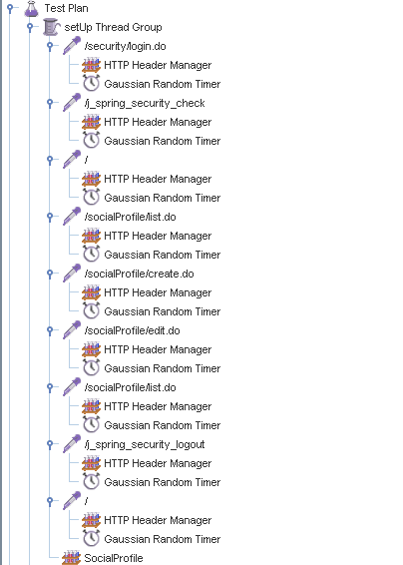

Aggregate Report:

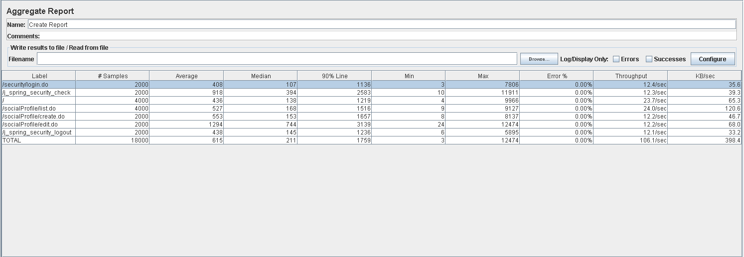



Thread properties:

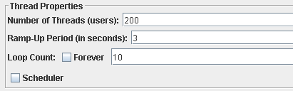

Graph Results:

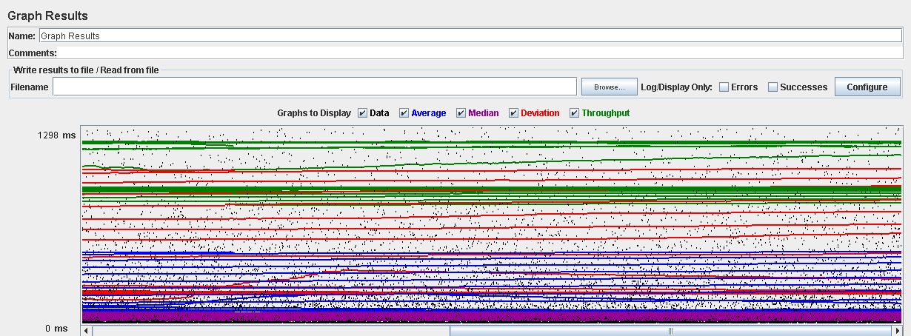

Performance Results:

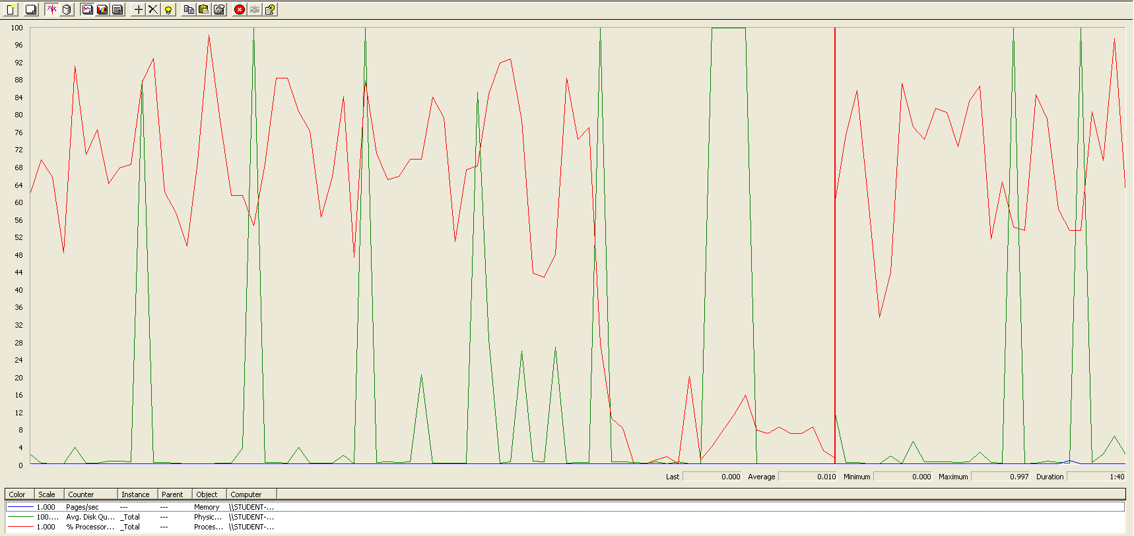

The CPU was always at its limit while the disk usage showed many peaks.

## Edit

Sequence:

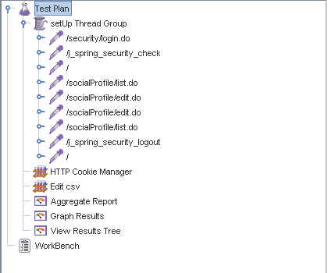

Aggregate Report:

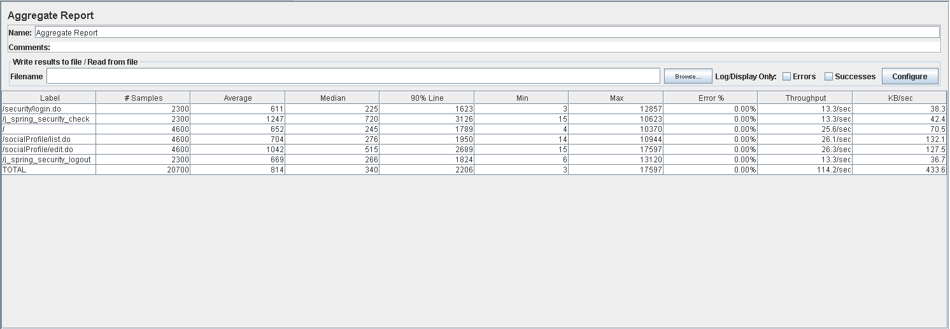

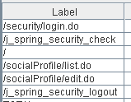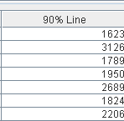

Thread properties:

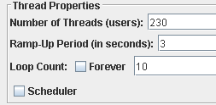

Graph Results:

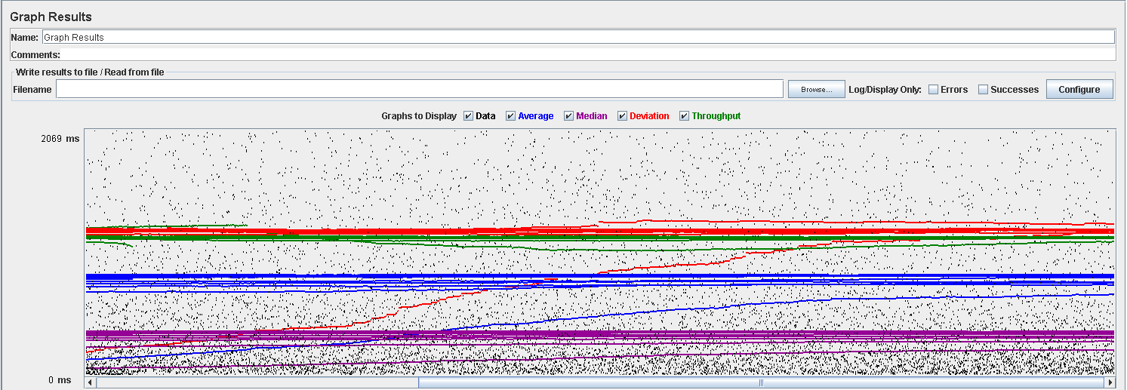

Performance Results:

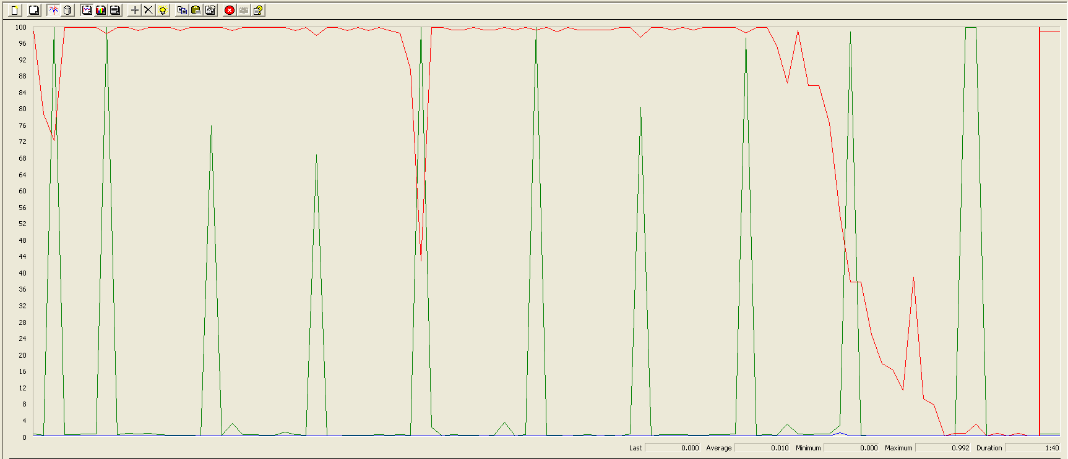

Again we can see that the CPU is always being used while the disk usage shows different peaks at times.

## 

## Delete

Sequence:

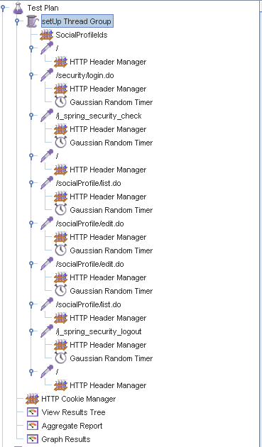

Aggregate Report:

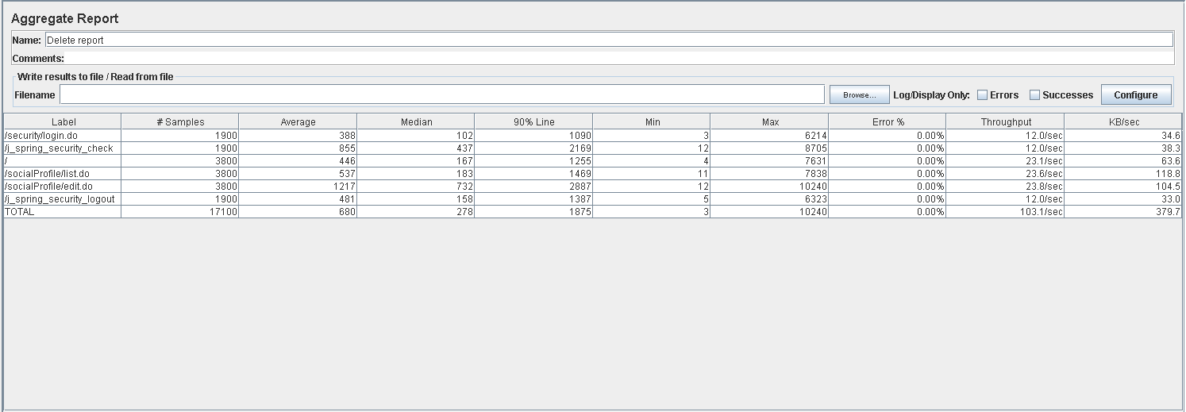

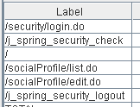

Thread properties:

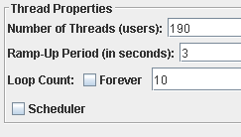

Graph Results:

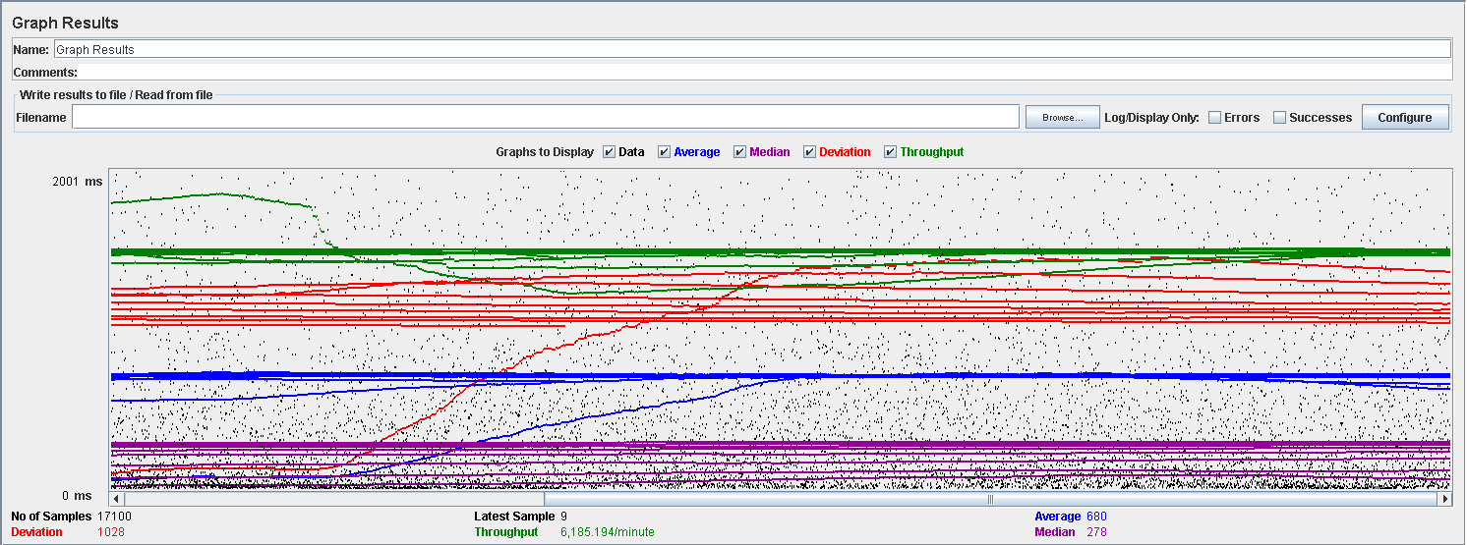

Performance Results:



Again we can see that the CPU is always being used while the disk usage shows some periodic peaks.

## Conclusion

The test was performed using:

CPU: i7 7700hq (2 cores in the virtual machine)

RAM: 4 GB (virtual machine)

For this use case we can say that the limitation occurs during the creation process, being the maximum of concurrent users 190.

# Actor

## Create

Sequence:

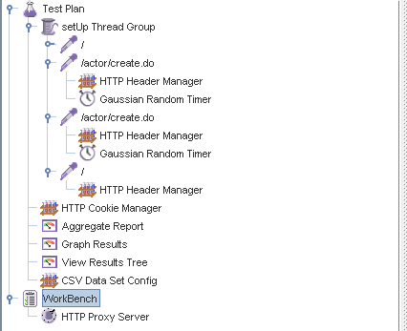

Aggregate Report:



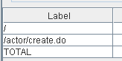 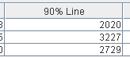 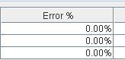

Thread properties:



Graph Results:

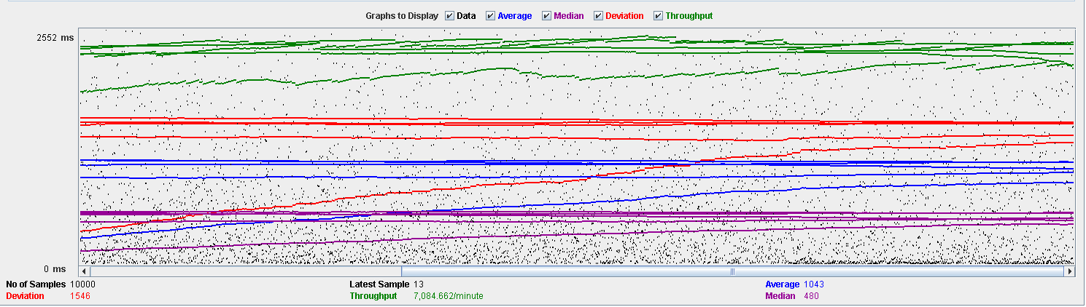

Performance Results:

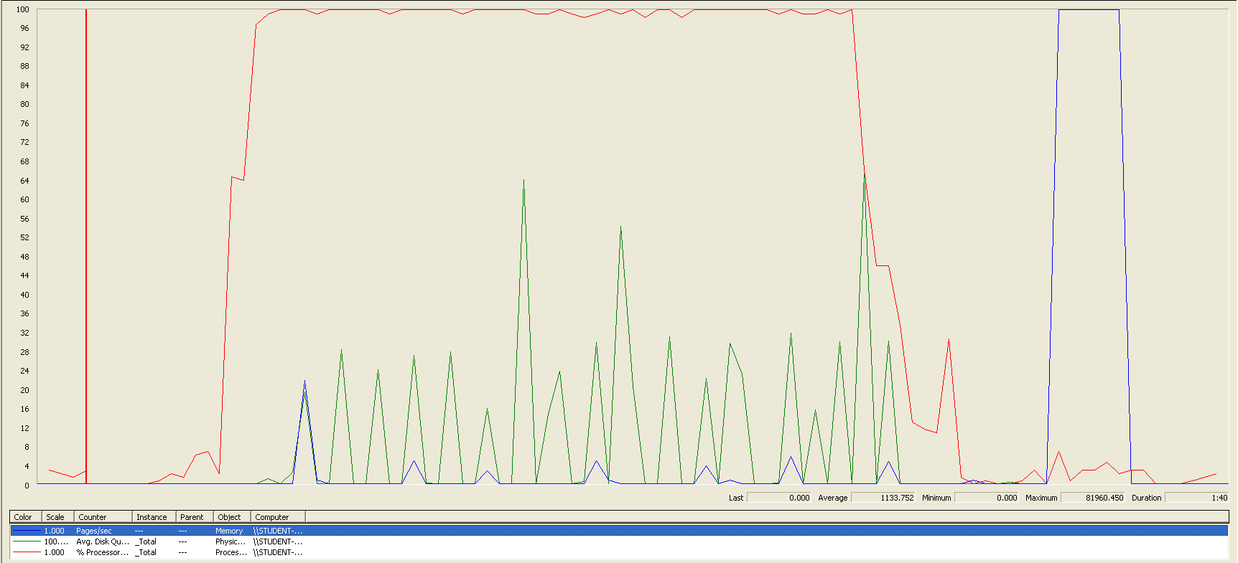

The CPU was always at its limit while the disk usage has a lot of peaks.

## Edit

Sequence:

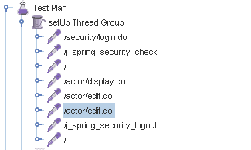

Aggregate Report:





Thread properties:

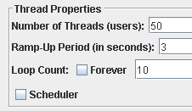

Graph Results:

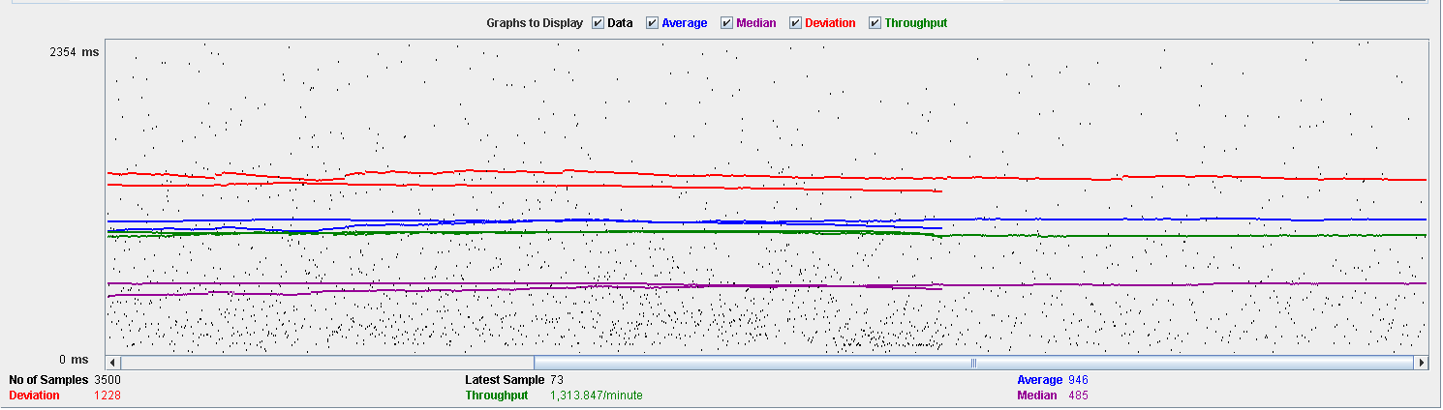

Performance Results:

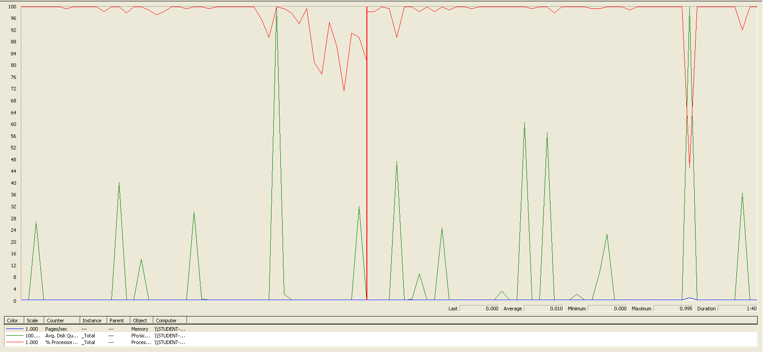

Again we can see that the CPU is always being used while the disk usage has some peaks at times.

## Delete

Sequence:



Aggregate Report:



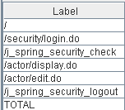

Thread properties:

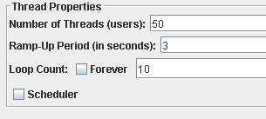

Graph Results:

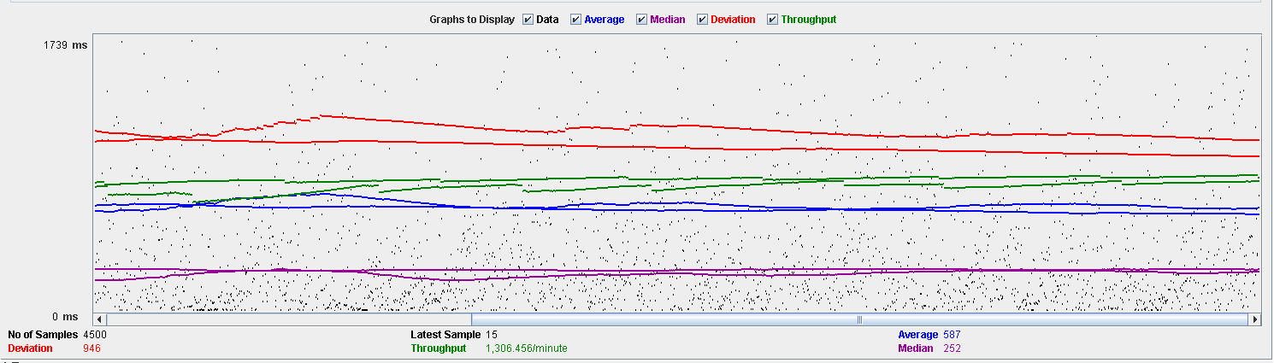

Performance Results:

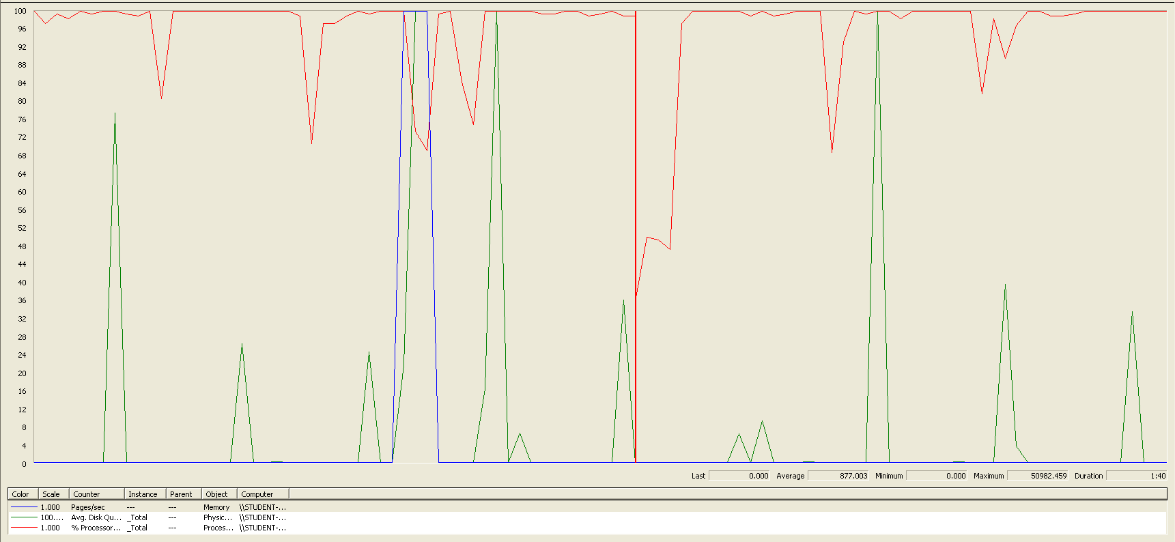

Again we can see that the CPU is always being used while the disk usage has different peaks.

## Conclusion

The test was performed using:

CPU: i7 7700hq (2 cores in the virtual machine)

RAM: 4 GB (virtual machine)

For this use case we can say that the limitation occurs during the creation process, being the maximum of concurrent users is 50.

# Application

## Create

Sequence:

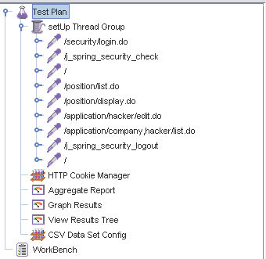

Aggregate Report:

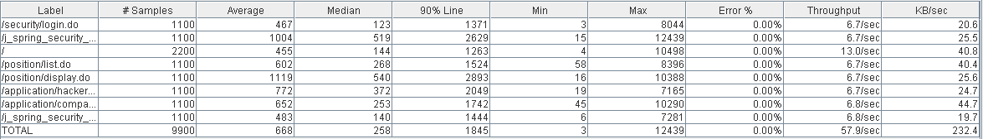

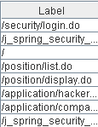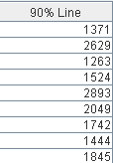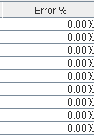

Thread properties:

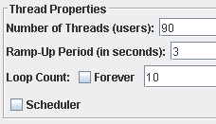

Graph Results:

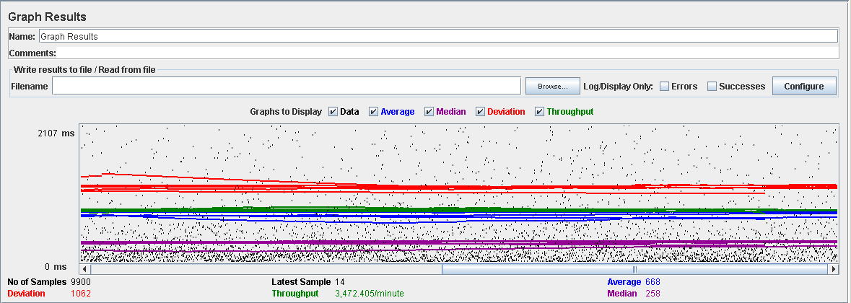

Performance Results:

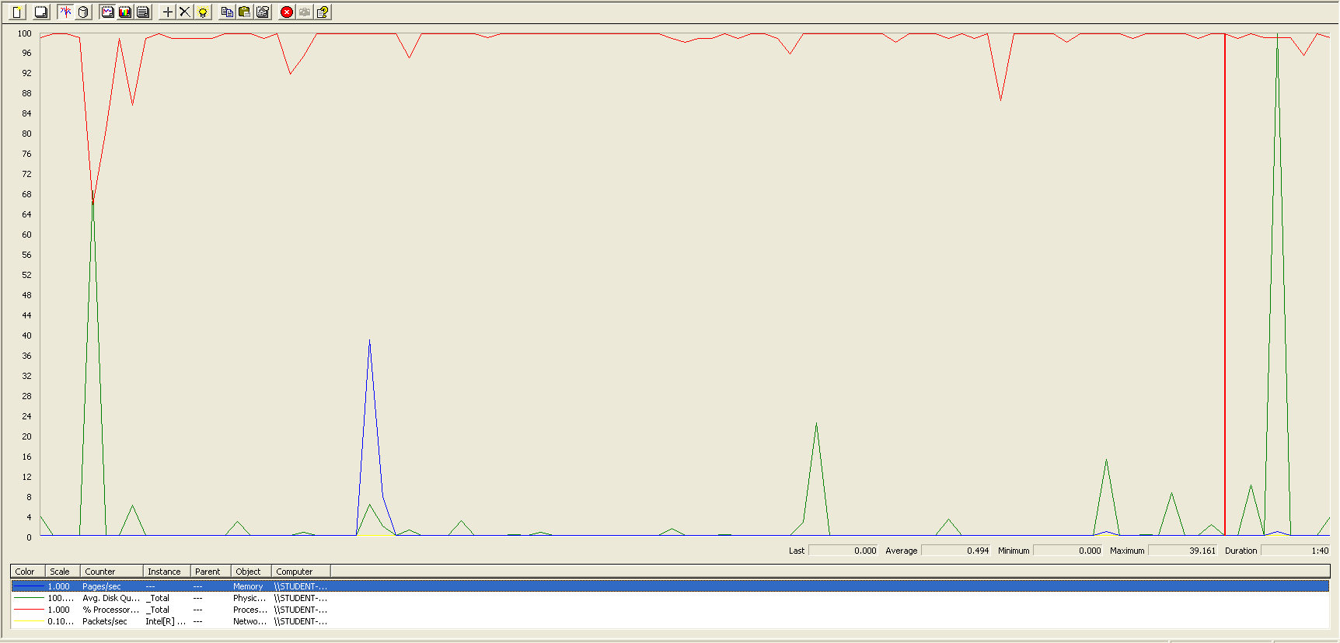

The CPU was always at its limit while the disk usage has some peaks.

## Edit

Sequence:

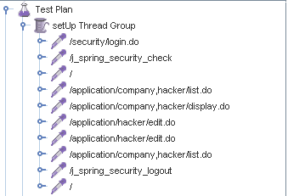

Aggregate Report:

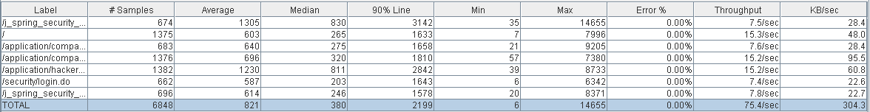

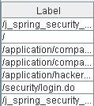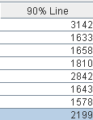

Thread properties:

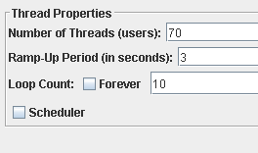

Graph Results:

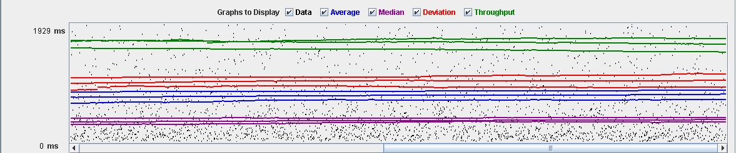

Performance Results:

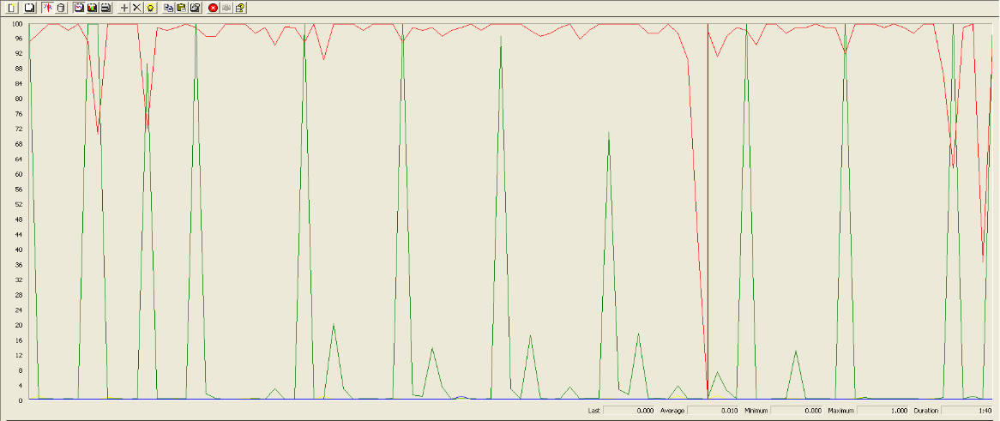

Again we can see that the CPU is always being used while the disk usage has low peaks at times.

## Delete

Sequence:

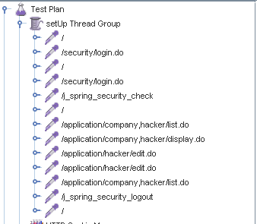

Aggregate Report:

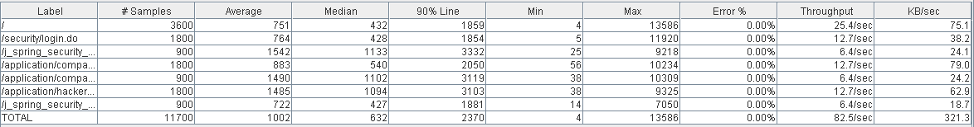

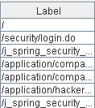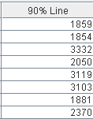

Thread properties:

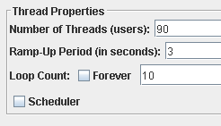

Graph Results:

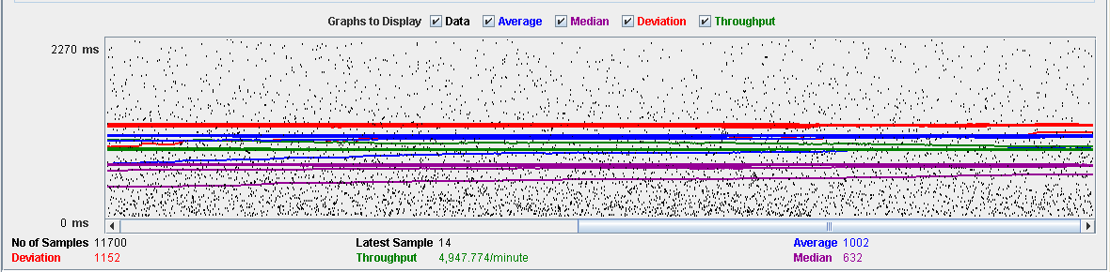

Performance Results:

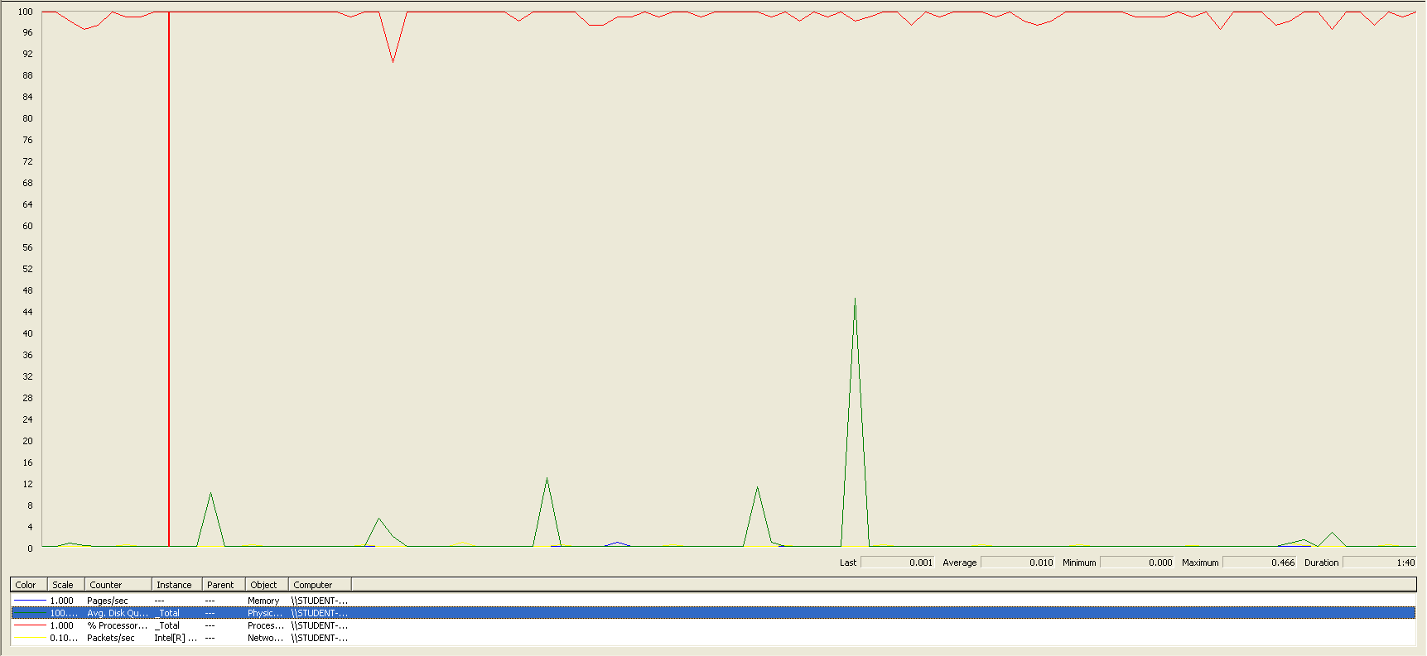

Again we can see that the CPU is always being used while the disk usage has different peaks.

## Conclusion

The test was performed using:

CPU: i7 7700hq (2 cores in the virtual machine)

RAM: 4 GB (virtual machine)

For this use case we can say that the limitation occurs during the creation process, being the maximum of concurrent users 70.

# Audit

## Assign

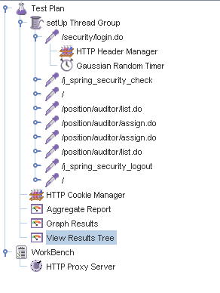

Aggregate Report:

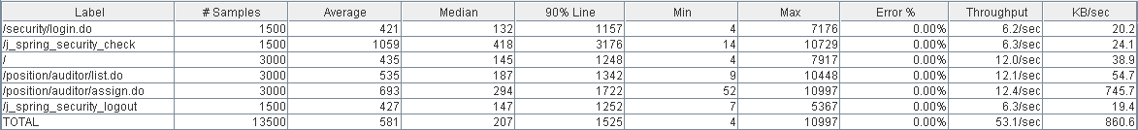



Thread properties:

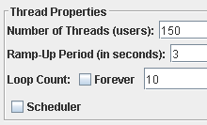

Graph Results:

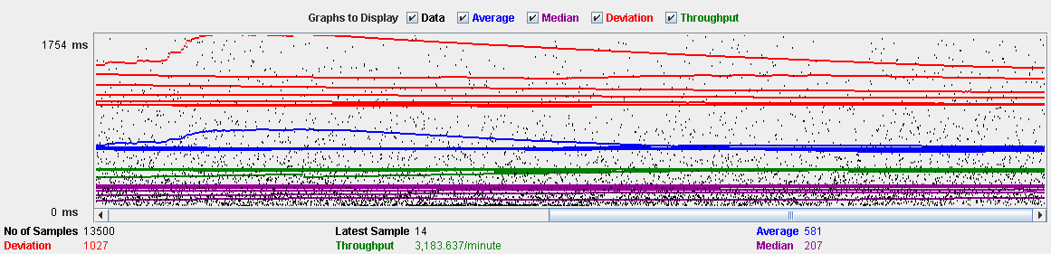

Performance Results:

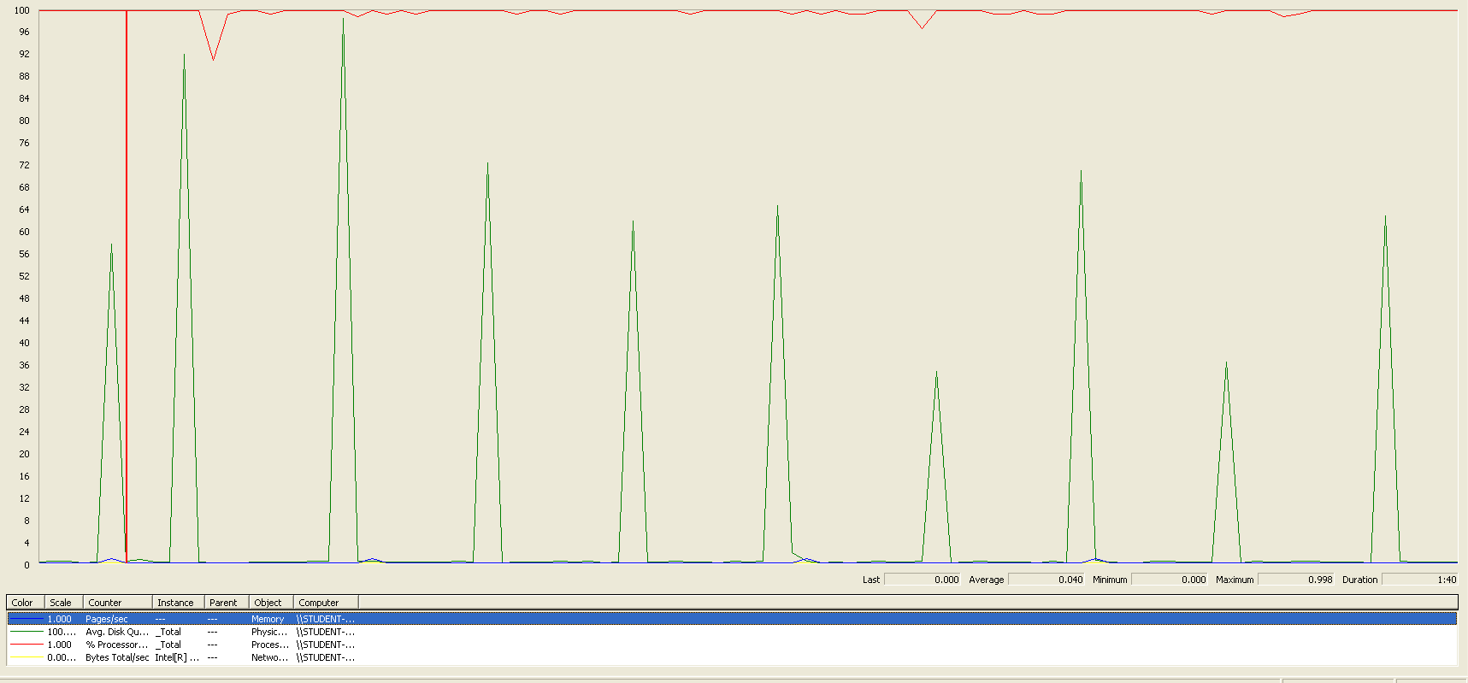

The CPU was always at its limit while the disk usage showed many peaks.

## Create

Sequence:

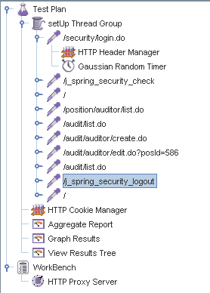

Aggregate Report:

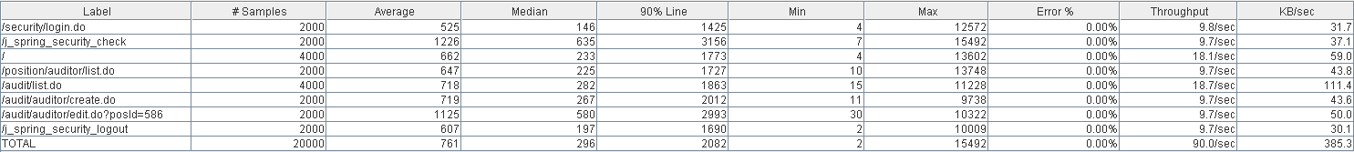



Thread properties:

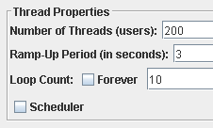

Graph Results:



Performance Results:

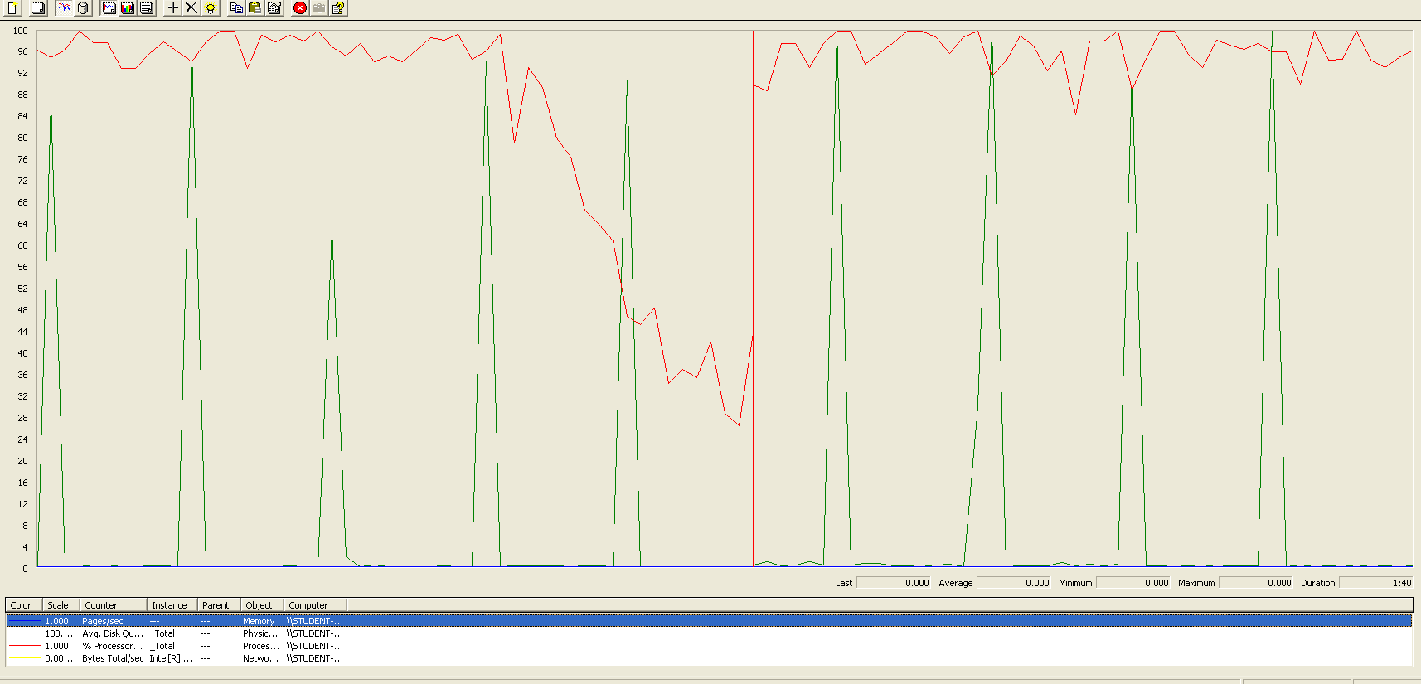

The CPU was always at its limit in various points of the execution while the disk usage showed many peaks.

## Edit

Sequence:

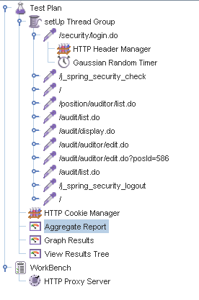

Aggregate Report:

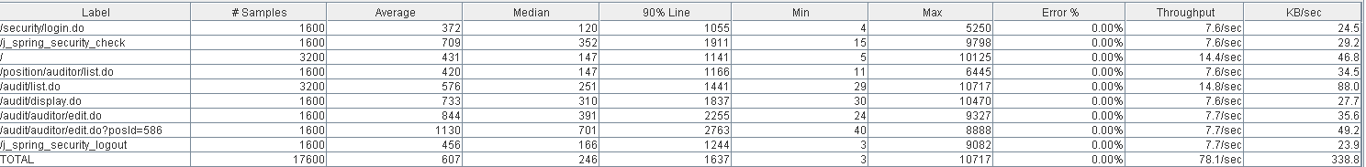



Thread properties:

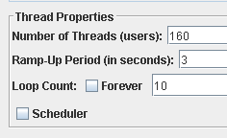

Graph Results:

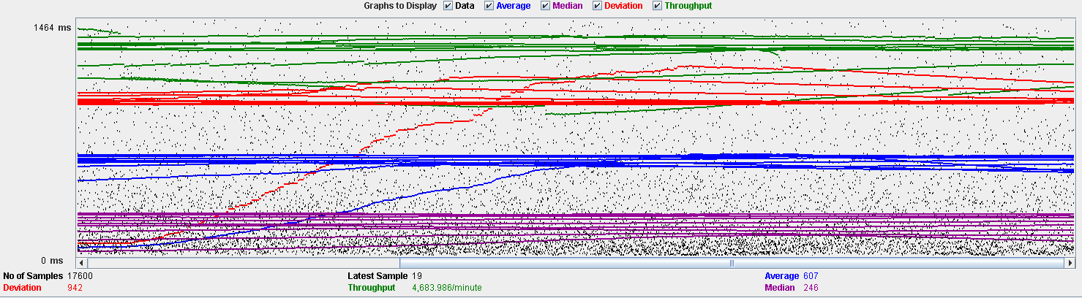

Performance Results:

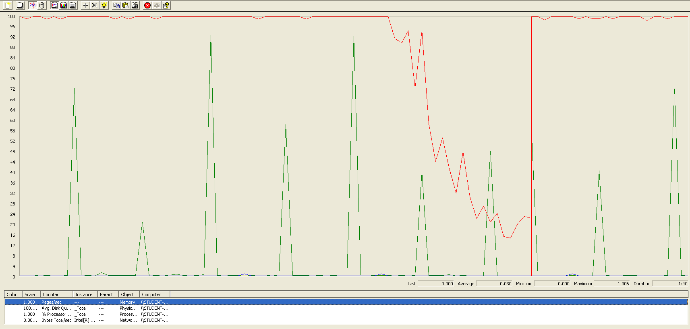

The CPU was always at its limit while the disk usage showed many peaks.

## Delete

Sequence:



Aggregate Report:

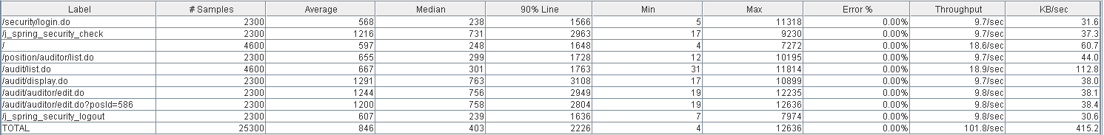



Thread properties:

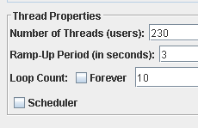

Graph Results:

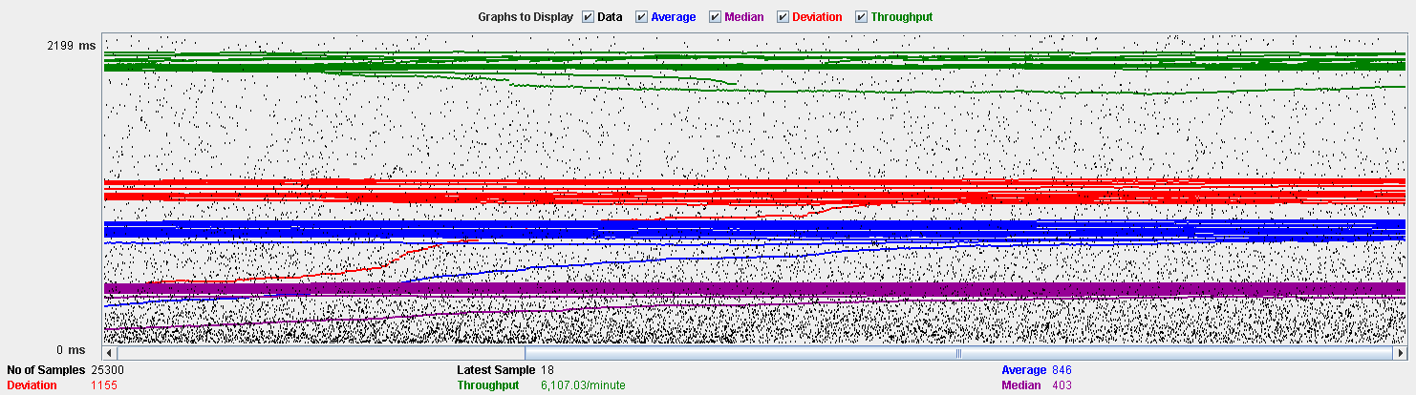

Performance Results:

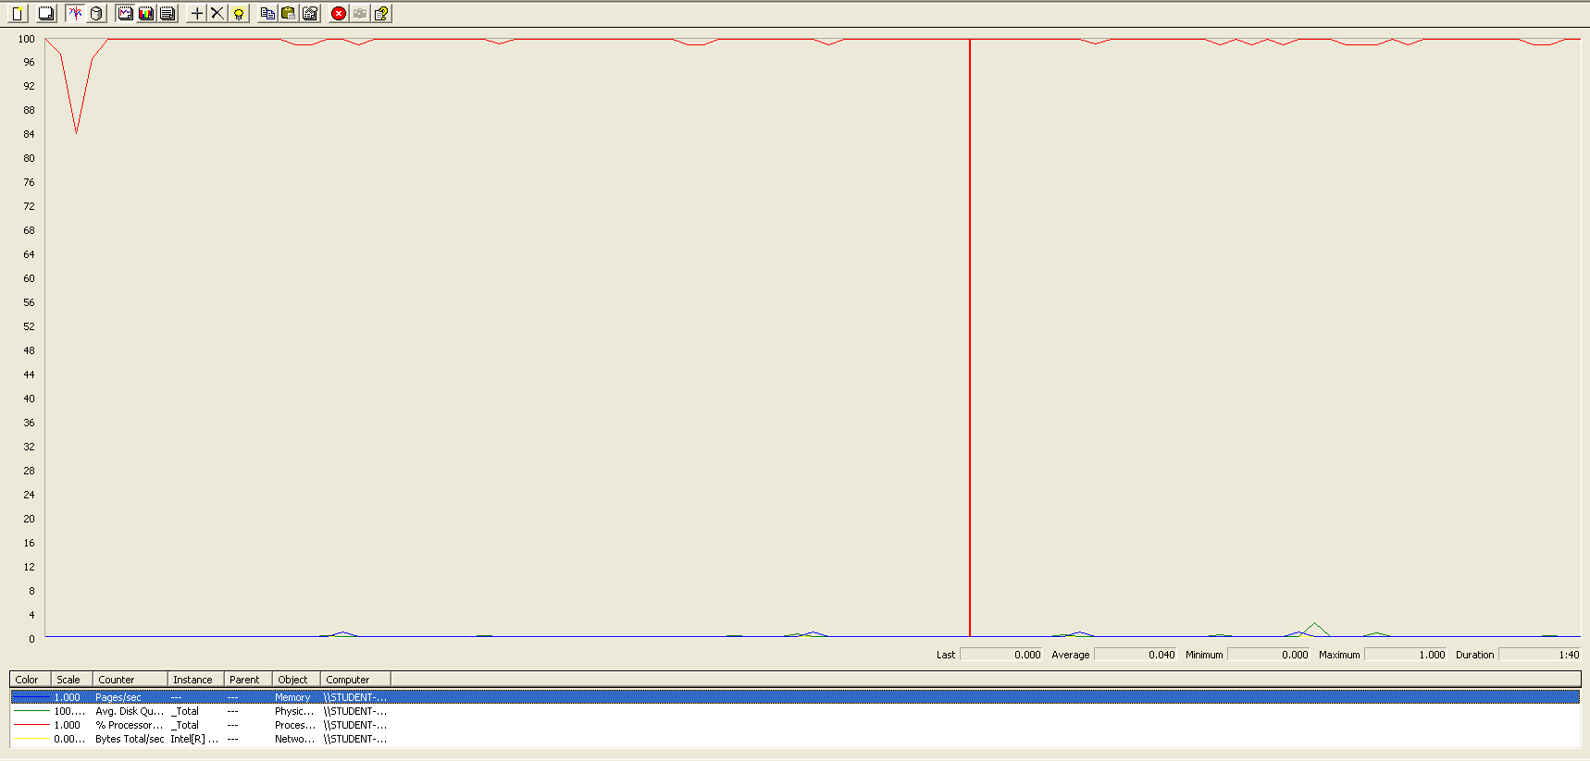

The CPU was always at its limit.

## Conclusion

The test was performed using:

CPU: i7 6700hq (2 cores in the virtual machine)

RAM: 4 GB (virtual machine)

For this use case we can say that the limitation occurs during the assign process, being the maximum of concurrent users 150.

# Sponsorship

## Create

Sequence:

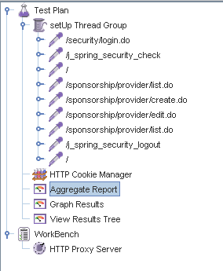

Aggregate Report:

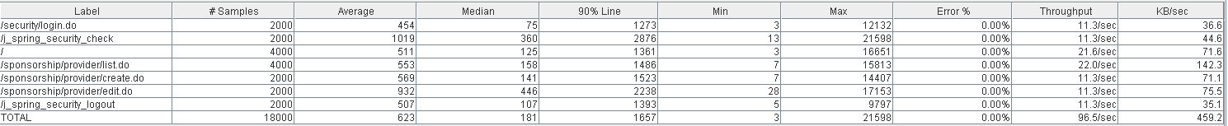



Thread properties:

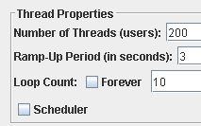

Graph Results:

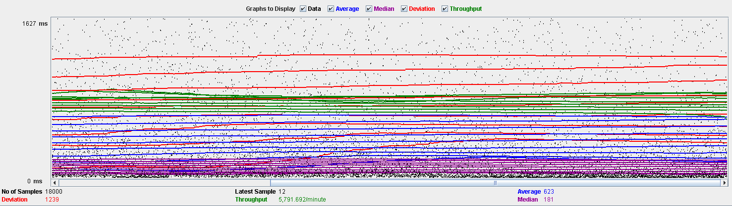

Performance Results:

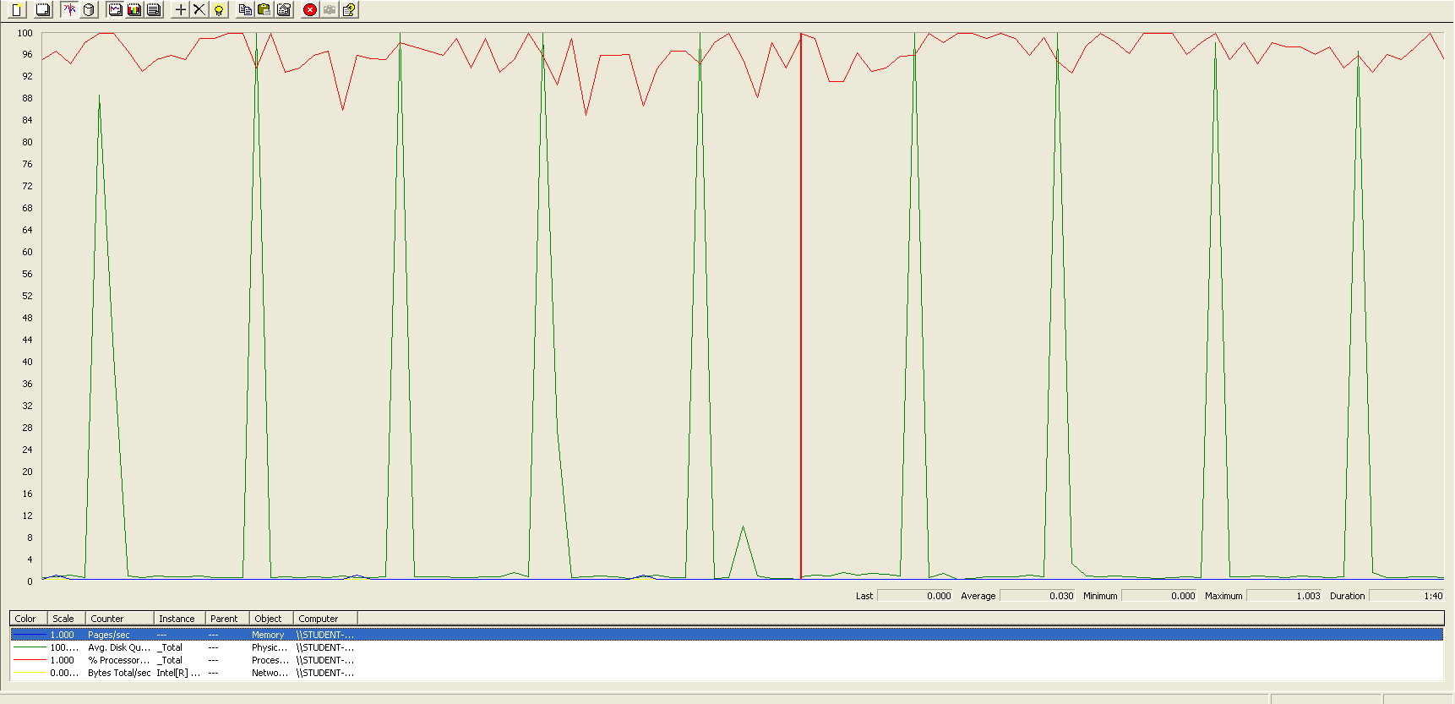

The CPU was always at its limit while the disk usage showed many peaks.

## Edit

Sequence:

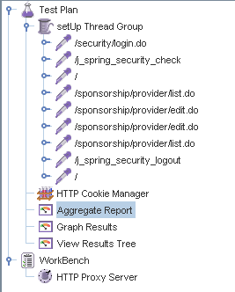

Aggregate Report:





Thread properties:

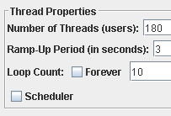

Graph Results:

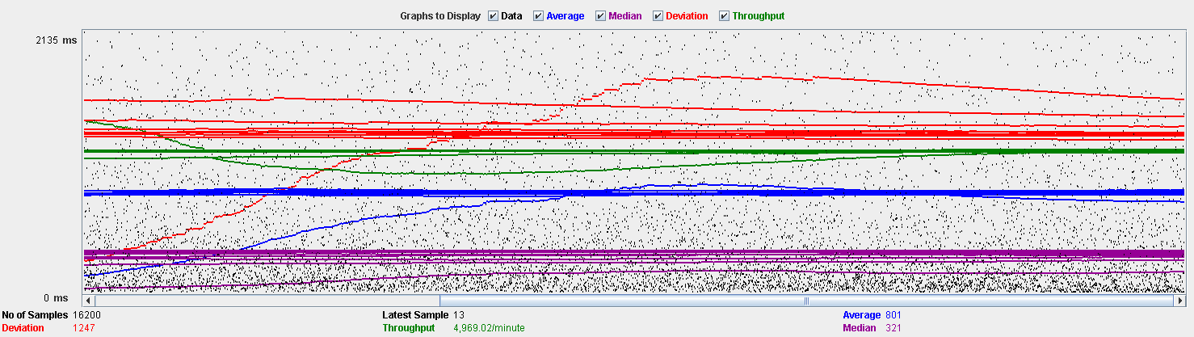

Performance Results:

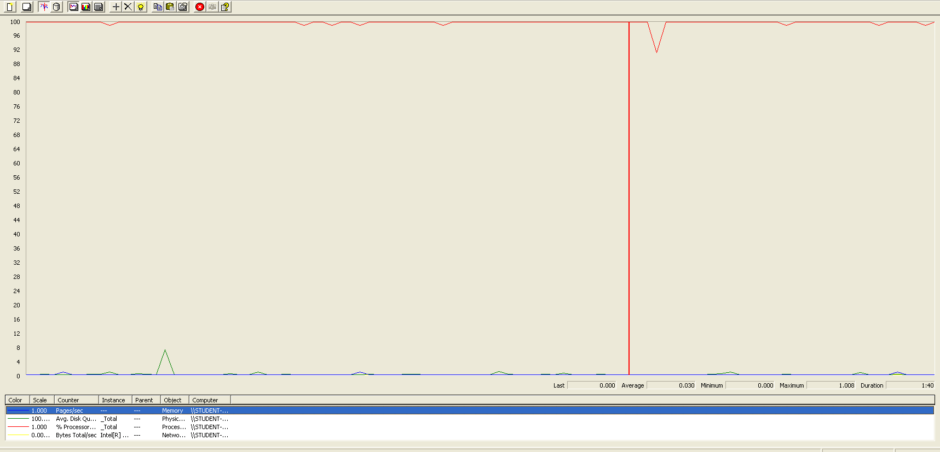

The CPU was always at its limit.

## Delete

Sequence:

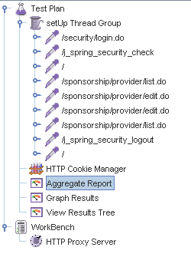

Aggregate Report:





Thread properties:

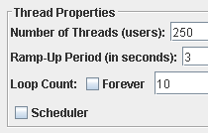

Graph Results:

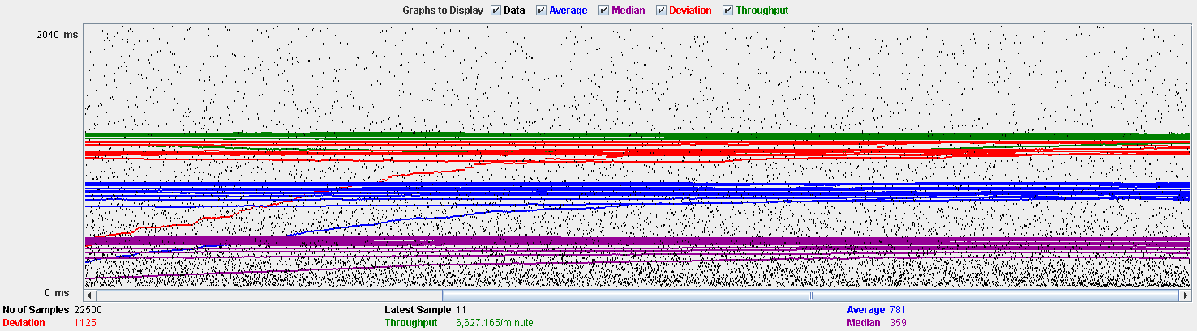

Performance Results:

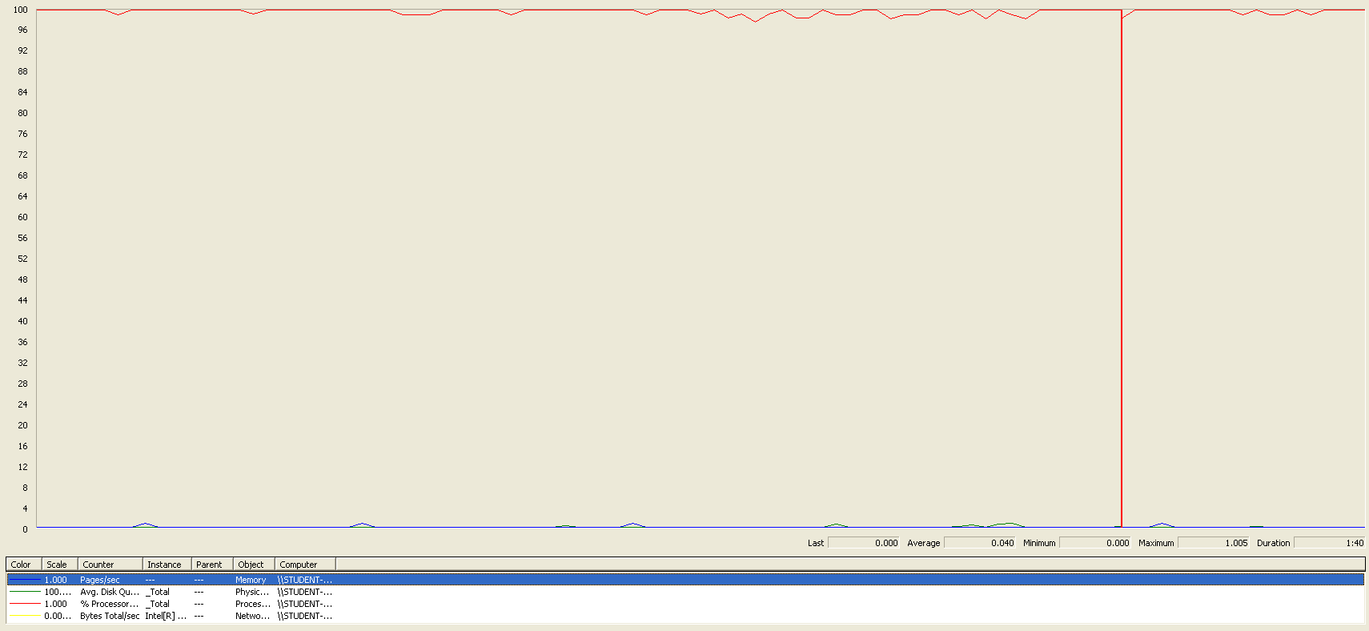

The CPU was always at its limit.

## Conclusion

The test was performed using:

CPU: i7 6700hq (2 cores in the virtual machine)

RAM: 4 GB (virtual machine)

For this use case we can say that the limitation occurs during the edit process, being the maximum of concurrent users 180.

# Item

## Create

Sequence:

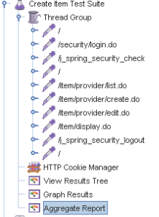

Aggregate Report:

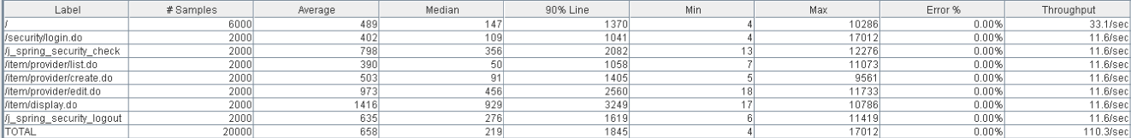

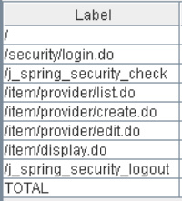 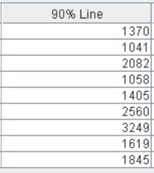 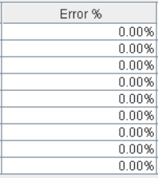

Thread properties:



Graph Results:

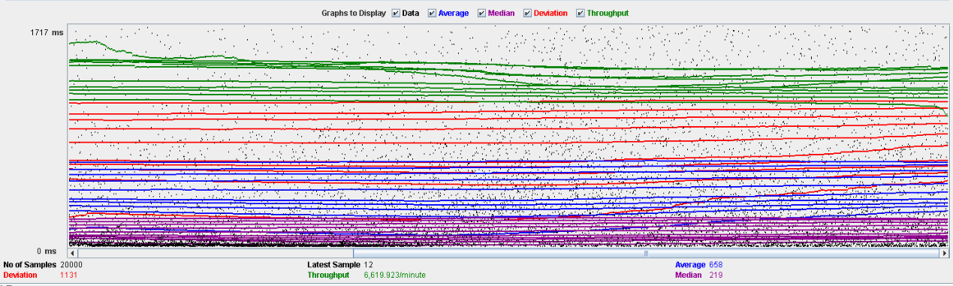

Performance Results:

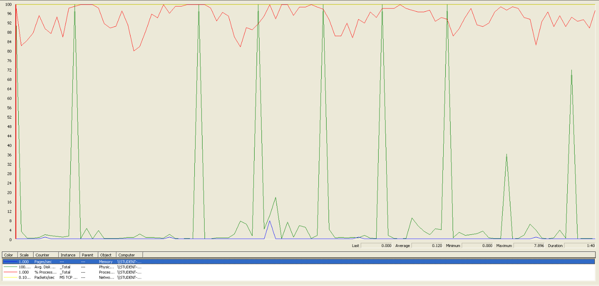

The CPU was always at its limit while the disk usage has some peaks.

## Edit

Sequence:

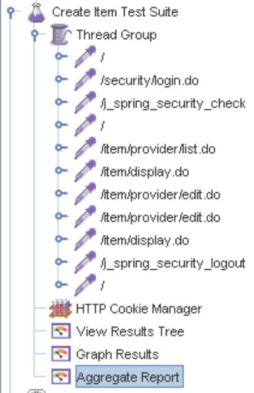

Aggregate Report:

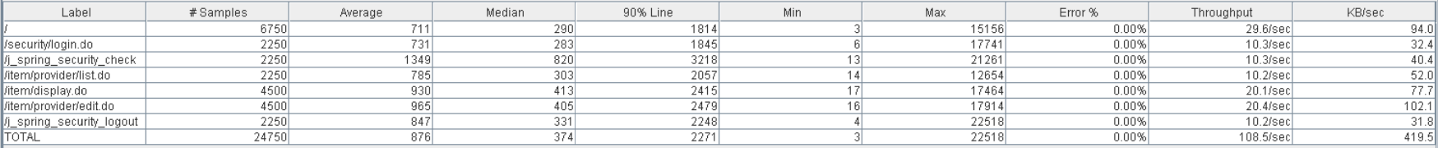

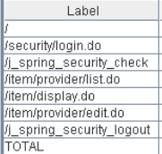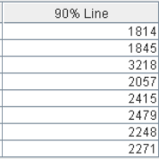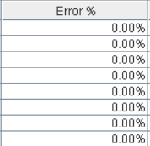

Thread properties:



Graph Results:

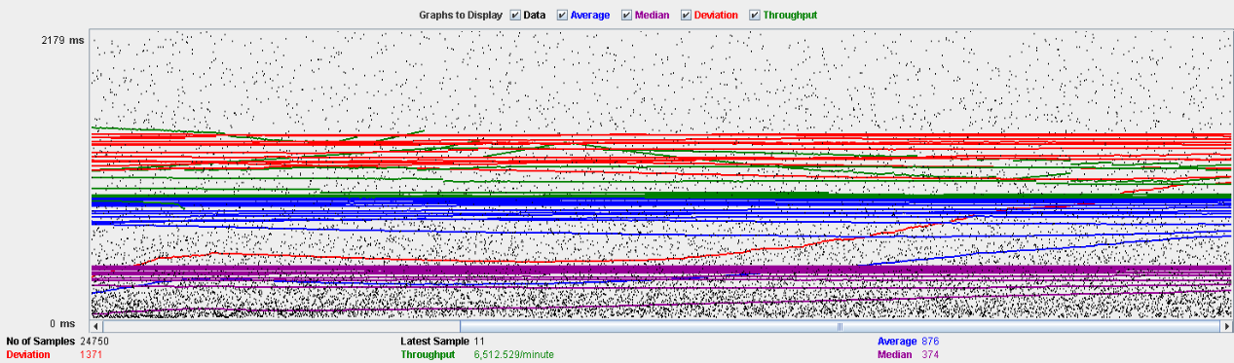

Performance Results:

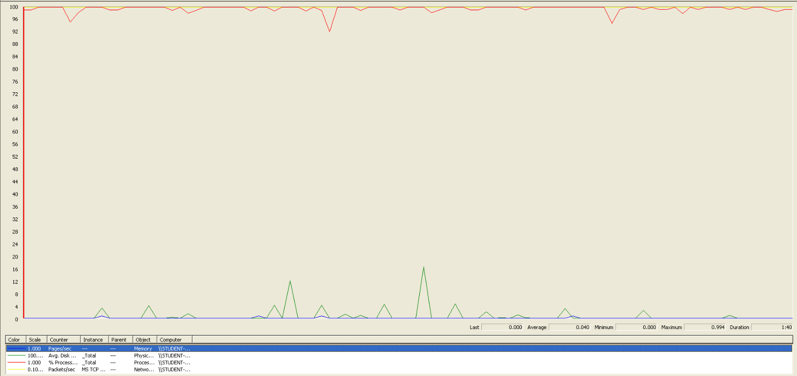

Again we can see that the CPU is always being used, is the problem in this use case.

## Delete

Sequence:

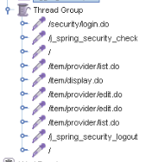

Aggregate Report:

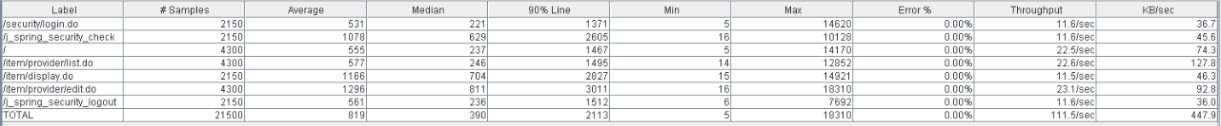

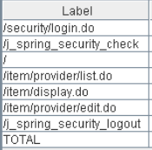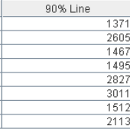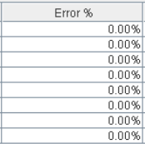

Thread properties:



Graph Results:

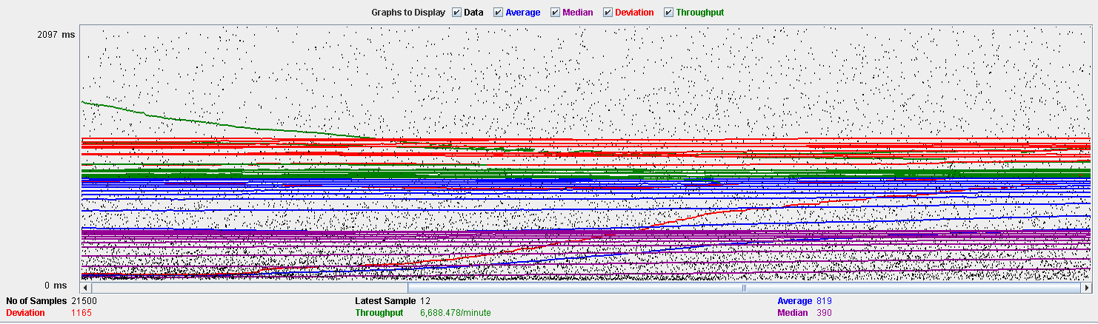

Performance Results:

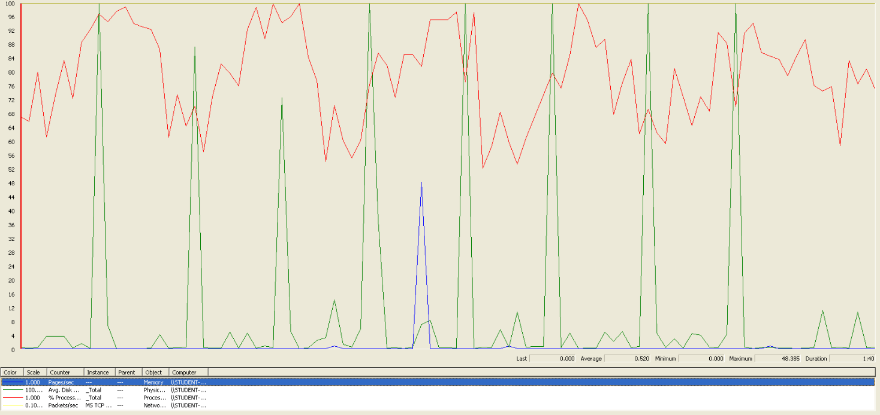

Again we can see that the CPU is always being used while the disk usage has different peaks.

## Conclusion

The test was performed using:

CPU: i5 7300hq (2 cores in the virtual machine)

RAM: 2 GB (virtual machine)

For this use case we can say that the limitation occurs during the creation process, being the maximum of concurrent users 190.

# Conclusion of the performance

As we can see in the tests above, the limitations of our system are in the message system, specially in the method of broadcasting a message (14 concurrent users). We think that this may be a bit unrealistic, because in a real environment won’t be many administrators sending multiple notifications. Due that, we consider that the limit of concurrent users for our system is 45 (sending a message).